

Nursery

Week beginning: 30th March 2020

This is a suggested plan as it can help your child to have a routine. Please don’t feel that you need to do all the suggested activities, be guided by your child and support them to learn through their play. Try and keep bedtime and mealtimes at the normal time and get up early in the morning as this would also help your child.
8.30-9.00 Breakfast and story time-story of the week is ‘The Very Hungry Caterpillar’ see link on the home learning page of Eric Carle sharing this story.
9.00-9.30 Physical activity- Andy's Wild Workouts, Series 1:1 Under the Sea on BBC iplayer or search Joe Wicks family PE lesson. (These are taking place at 9.00am every morning)
9.30-11.00 Learning through play (see below for suggestions of activities you could do with your child)
11.00-12.00 Outdoor play (see below for suggestions of activities you could do with your child)
12.00-1.30 Lunchtime
Can your child help you prepare lunch for example can you support them to chop vegetables. Can they set the table and count how many forks, knifes etc they will need? After lunch can your child help you wash the dishes and put things away. They will love the responsibility of helping you. They could also help you with other household jobs like dusting, folding washing, putting clothes away, pairing socks etc.
1.30-2.00 Sing songs and rhyme of the week and practice counting to 10-(see ideas below)
2.00-3.30 Learning through play (see below for suggestions of activities you could do with your child)
3.30-4.30 Family walk around the local area (see ideas below)
4.30-5.30 Dinner time- Can your child help you prepare for dinner?
5.30-6.00 Cuddle up for a story with someone in your family
Learning through play ideas | Outdoor learning ideas including family walk
Support your child to write their name. This is in your learning packs. You could use felt tips, pencils, shaving foam or use chalk outside.  Draw pictures of caterpillar's flowers and other things you may have seen in your garden or on your walk.  Can your child talk about the things they have drawn and give meaning to their marks?  Can make a little book about Spring?  Could you use the internet to search for more information about different creatures?  Could you make a bookmark and post it to one of your neighbours who is perhaps elderly and might need cheering up?  Can your child retell the story of ‘The Very Hungry Caterpillar’ to you?  Can they name the food that the caterpillar ate?  Do they understand what happens to the caterpillar?  Make some playdough with your child. See recipe below and ideas for things you could do with the playdough. | Look at signs that Spring is here.  Listen to the birds singing, buds appearing in the trees.  Talk to your child about the flowers in your garden or local area starting to bloom and the new colours they can see.  What flowers can your child see?  Can you introduce them to the names of different flowers?  Can they count how many flowers they can see? For example can they count and find 3 daffodils?  What creatures can you find with your child?  Turn over a leaf and see if you can find a caterpillar.  Now the weather is getting warmer you should be able to see bees, wasps and butterflies too.  Dig in your garden what other things can you find?  Play with a ball or another object (for example rolled up paper or pair of socks) with your child.  Can they get the object into a bucket?  Can they count how many times they get the object into the bucket?  Call out a number. Can your child hop or jump that many times?
Rhyme/poem of the week | Songs to sing together
(by Louise Gribbons)  The world it got so busy  There were people all around.  They left their germs behind them;  In the air and on the ground.  These germs grew bigger and stronger.  They wanted to come and stay.  They didn’t want to hurt anyone-  They just really wanted to play.  Sometimes they tried to hold your hand,  Or tickled your throat or your nose.  They could make you cough and sneeze  And make your face as red as a rose.  And so these germs took over.  They started to make people ill,  And with every cough we coughed  More and more germs would spill.  All the queens and kings had a meeting.  “It’s time to clean the world up!” they said.  And so they had to close lots of fun stuff,  Just so these germs couldn’t spread.  We couldn’t go to cinemas  Or restaurants for our tea.  There was no football or parties,  The world got as quiet as can be.  The kids stopped going to school,  The mums and dads went to work less.  Then a great, big, giant scrubbing brush  Cleaned the sky and the sea and the mess!  Dads started teaching the sums,  Big brothers played with us more,  Mums were in charge of homework  And we read and played jigsaws galore!  The whole world was washing their hands  And building super toilet roll forts!  Outside was quiet and peaceful,  Now was the place for all sports.  So we played in the world that was home  And our days filled up with fun and love,  And the germs they grew smaller and smaller  And the sun watched from up above.  Then one morning the sun woke up early,  She smiled and stretched her beams wide.  The world had been fully spring cleaned,  It was time to go back outside!  We opened the door oh so slowly  And breathed in the clean fresh air.  We promised that forever and always  Of this beautiful world we’d take care! | This is the way we wash our hands,  Wash our hands,  Wash our hands  This is the way we wash our hands  To STOP Coronavirus  Head, shoulders, knees and toes  Poem  Little Arabella Miller  Found a wooly caterpillar  First she put it on her mother  Then upon her baby brother  Both said, “Arabella Miller, take away that caterpillar!”  Days of the week song (Your child will know this song)  Monday,Tuesday, Wednesday, Thursday,  Friday, Saturday, Sunday too,  1 2 3 4 5 6 7 days  Each day different and everyday new.  (Refer to the Very Hungry Caterpillar Story, what did the caterpillar eat on each day?)  Walk fingers up your child’s back  Who’s that tickling my back said the wall?  Me said the caterpillar,  I’m Learning to crawl  Poem:  The fuzzy Caterpillar  Curled up on a leaf  Spun her little Chrysalis  And then fell fast asleep  She dreamed that she could fly  And later when she woke up  She was a butterfly  Rhyme:  Five little butterflies by the door.  One flew away, then there were four.  Four little butterflies by the tree.  One flew away, then there were three.  Three little butterflies up in the blue.  One flew away, then there were two.  Two little butterflies out in the sun.  One flew away, then there was one.  One little butterfly now all alone.  She was so lonely, she flew home.

Other information
Make Playdough Together!
Recipe:

2 cups plain flour
1 cup salt
2 cups warm water
2 tablespoons cooking oil

Mix and knead

Have fun!!!

Tune into Youtube...Dough Disco (link on Home Learning page)
Or
Make two balls, put them together to make a chick
Can you make a caterpillar?
Can you make short caterpillars and long caterpillars?
What else can you create?

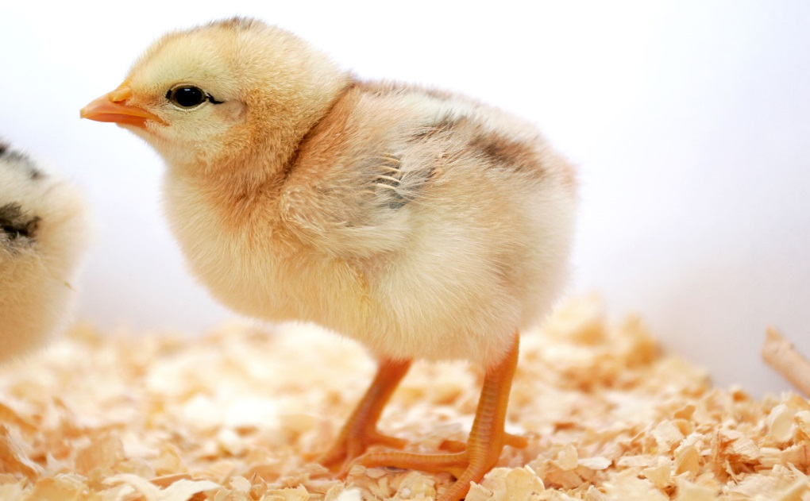

Make paper plate flowers!

Can your child hold a scissors correctly?
Can they make snips in the plate?
Can they choose what colour they want to colour in/paint their flower, stem etc?

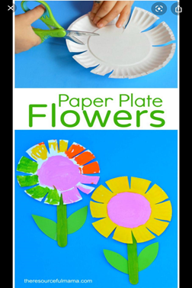

The very hungry Caterpillar sorting activity!

Can you help you child to sequence the story using these pictures?
Or
You ca print out 2 copies and match the pictures together by playing snap
Or
by placing them upside down and taking turns to turn them over. The family member with the most pairs wins.



