
Design an advert
Design an advert for a magazine or the Internet for
A time machine
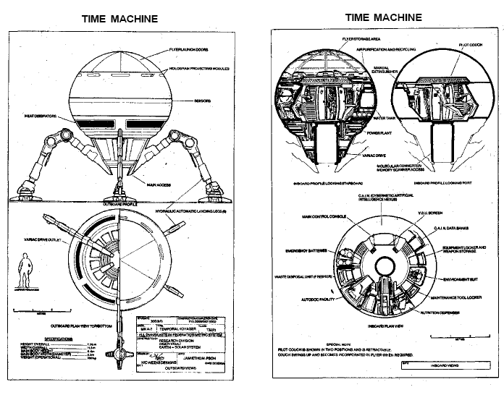

Design an advert
Design an advert for a magazine or the Internet for
A trip into space.

Alliteration
Make an alliterative sentence about another member of the class.

Rory ran round raging rhinos.

Design a loop game
Make a language loop game where you have the answer to someone else’s description then you give a description of a word for the next person.
Giraffe | A tool for cutting wood.

Axe | Someone who wears a uniform

