Hello,

I am writing to you to ask for your help!
Your task is to design an invention that will help children to learn from home. It can be as creative as you would like!
Remember to label the parts of your invention and write why they would help children learning from home!

Thank you very much,
Mysterious Inventor

An example: Robot teacher
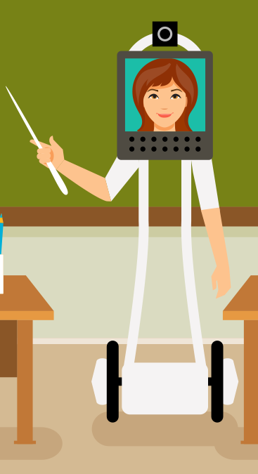
The wheels on the robot teacher allows it to move around quickly to help the children.
The robot teacher will have a screen and a camera. The teacher can ask the children questions and hear their answers.

