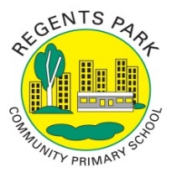
Regents Park Community Primary School
Remote Learning Overview 2020 - 2021
Weeks beginning 4th January

Day | Phonics |  | Reading |  | English |  | Maths |  | Topic  including PSHE/P4C per week
Tues | Lesson 1: i - child  https://www.youtube.com/watch?v=JiS2-09vBnY&feature=youtu.be  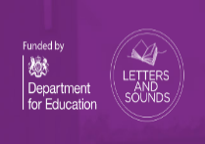  A worksheet is available on BGFL |  | Reading for 30mins  Collins ebook Library |  | The Quangle Wangle’s Hat  Use the sheet on BGFL to complete the activity  - What is a Quangle Wangle? |  | Lesson 1 - Make Equal groups  https://whiterosemaths.com/homelearning/year-2/week-1-number-multiplication-and-division/ |  | Lesson 1- Celebrations  Watch this with your child.: https://www.bbc.co.uk/cbeebies/shows/lets-celebrate  Make an A-Z list of celebrations around the world. How many can they find? What have they celebrated this year with their friends and family? Can they remember celebrating their birthday? How did they celebrate their birthday? Could they draw a picture of their special celebration? Can they interview a family member about their favourite celebration? What did they do? Who can they remember?  P4C- Discuss:  Is it worse to fail at something or never attempt it in the first place?  You can write your ideas down on a document and upload onto BGfL365.
Wed | Lesson 2: a – paper  https://www.youtube.com/watch?v=Es3QUQubRA8&feature=youtu.be  A worksheet is available on BGFL |  | Reading for 30mins  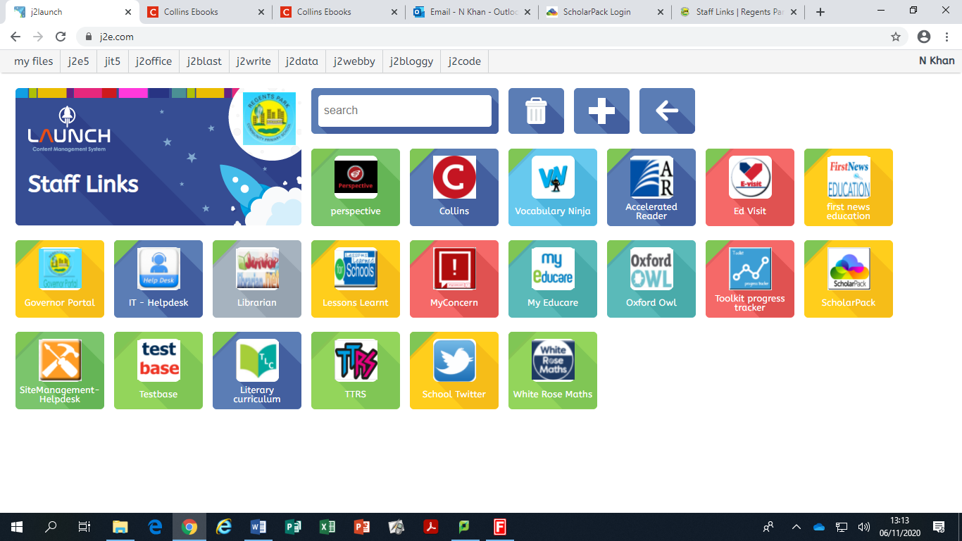  Collins ebook Library |  | Reading Challenge 1: Listen to a soundcloud recording of the poem here: https://soundcloud.com/talkforwriting/quangle/s-x9rd3d4h6c2  You can also watch a video of the poem being read by Griff Rhys Jones here: https://www.youtube.com/watch?v=Ttv4H8YZ9HE  Now complete the activity on BGFL  - Three read, imagine and think activity |  | Lesson 2 - Add Equal groups  https://whiterosemaths.com/homelearning/year-2/week-1-number-multiplication-and-division/ |  | Lesson 2- Create a celebration card for a family member.  What will you put on the front? Will it be pictures, or will they write a birthday poem? Can you use different materials to design your celebration card?  P4C- Discuss:  If you could choose just one thing to change about the world, what would it be?  You can write your ideas down on a document and upload onto BGfL365.
Thurs | Lesson 3: ow – snow  https://www.youtube.com/watch?v=GS5rZnYcNnw&feature=youtu.be  A worksheet is available on BGFL |  | Reading for 30mins  Collins ebook Library |  | Use the sheet on BGFL to complete the activity  - Hat talk and Vocabulary activity |  | Lesson 3 – Multiplication using the Symbol  https://whiterosemaths.com/homelearning/year-2/week-1-number-multiplication-and-division/ |  | Lesson 3- Bake a cake  Weigh out the ingredients and bake a cake for a celebration. Can you write the instructions and send them to a friend? Can you tweet their school with a photo of their cake and instructions or upload it to BGfL365 so that your teachers can see it?  P4C- Discuss  What is true happiness?  You can write your ideas down on a document and upload onto BGfL365.
Fri | Lesson 3: u – unicorn  https://www.youtube.com/watch?v=8LufmGmCryk&feature=youtu.be  A worksheet is available on BGFL |  | Reading for 30mins  Collins ebook Library |  |  |  | Lesson 4 – Multiplication sentences from pictures  https://whiterosemaths.com/homelearning/year-2/week-1-number-multiplication-and-division/ |  | Lesson 4- Design a celebration party  Ask your child to choose a celebration. Who would they invite? Get them to make a list of things they will need? (banners, balloons etc...) Would they have to have a dress code? Can they design a celebration invite? On a piece of paper can they think about the colours and pictures they may have  P4C- Discuss  Is it more important to be liked or respected?  You can write your ideas down on a document and upload onto BGfL365.

