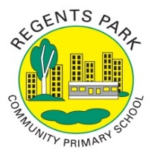
Regents Park Community Primary School
Home Learning 2019 – 2020 EYFS – Summer Term 2 Week 7

 | Fun exercise  Session | Phonics |  | Literacy – writing / mark making/ drawing |  | Snappy maths & games | Outdoor learning | Topic fun -  Creating and making | Story time
Monday | Let’s get fit with the firefighters  Keep fit session | Click on the link for daily phonics lessons  daily phonics |  | This week our focus story is The Gruffalo. Listen to it here.  https://www.bbc.co.uk/iplayer/episode/b00pk64x/the-gruffalo |  | Then follow the link to daily maths lessons here  https://whiterosemaths.com/homelearning/early-years/  This week’s story is How Many Legs. You can listen to it here https://www.youtube.com/watch?v=gmUY5bXkVKQ | Go on a walk in your local area or park. Can you find a Gruffalo, mouse, owl, fox and snake?  Talk about what these animals look like. Which other animals can you see?  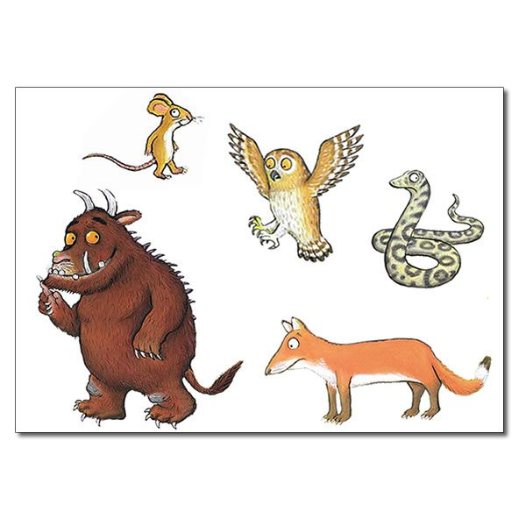 |  | Listen to an audio book online. Click here to choose a story to listen to: https://stories.audible.com/start-listen
Tuesday | Session 2 of the firefighters keep fit session  Keep fit session 2 | Click on the link for daily phonics lessons  daily phonics |  | Look at the picture of the Gruffalo below. Can you describe him?   |  |  | Use some natural materials to make a house for the mouse so that he can hide from the Gruffalo.  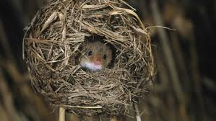 |  | Choose a book from the Oxford Owl website for your child to read. Click here to register and log in: https://home.oxfordowl.co.uk/books/free-ebooks/
Wednesday | Session 3 of firefighters keep fit  keep fit session 3 | Click on the link for daily phonics lessons  daily phonics |  | Have a go at writing the recipe for Gruffalo Crumble. |  |  |  | Can you make Gruffalo crumble with an adult?  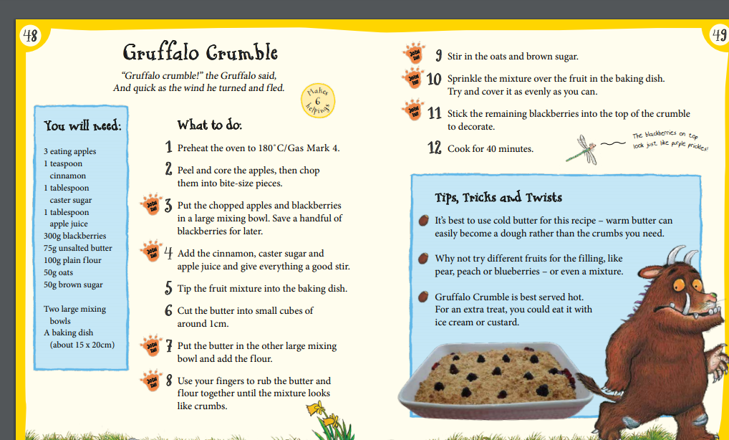 | Click on the Bug Club link and read a story: https://www.activelearnprimary.co.uk/login?c=0
Thursday | Frozen Yoga adventure  Yoga session - frozen | Click on the link for daily phonics lessons  Daily Phonics |  |  |  |  |  |  | Share a favourite story with your child.
Friday | Spider power Yoga  Yoga session - Spider power | Click on the link for daily phonics lessons  Daily Phonics |  |  |  |  |  |  | Listen to a story read by one of the Reception teachers. Click here for the video resource: https://regents-park-community-primary-school.primarysite.media/playlist/eyfs_homelearning

