
Regents Park Community Primary School
Home Learning 2019 – 2020
Week 7: 18.05.2020
*All work needs to be put onto Seesaw!*

Week beginning: | English including SPaG |  | Maths |  | Topic including Spanish | PE including Outdoor Learning | Reading for Pleasure
Monday | Listen to Mrs McDonald read chapter 6 and answer the following questions.  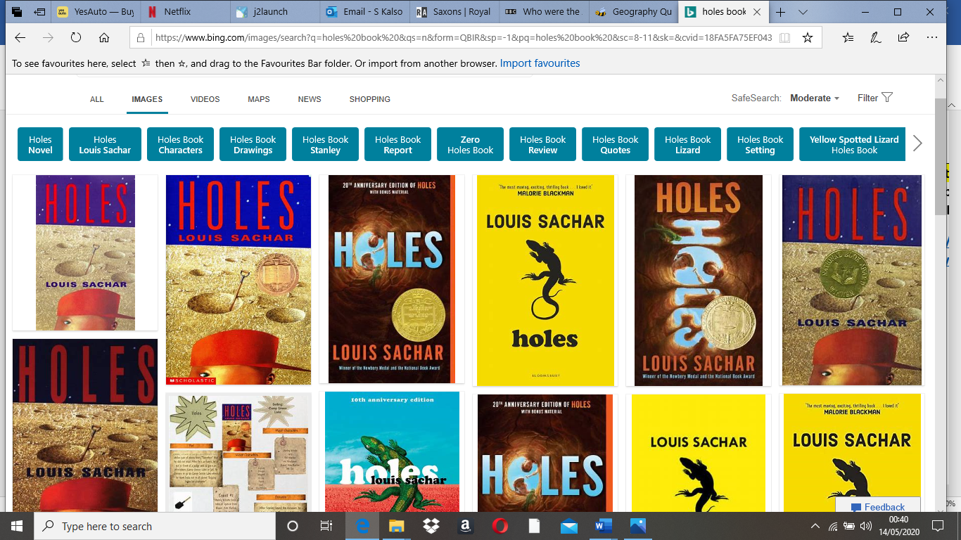  - Why did the teachers never take Stanley’s complaints about Derrick Dunne seriously?  - Why did Stanley feel like he was holding destiny’s shoes?  - Why did the patrol police car pull up next to Stanley?  - What do we know about why Stanley has been arrested and sent to Camp Green Lake now?  - The judge described Stanley’s crime as ‘despicable’. Can you think of a synonym that can be replaced with this adjective? |  | Practise your times tables using time table rockstars  Make sure you are practising for the year 5 and 6 TTRS competition! |  | Spanish  http://www.crickweb.co.uk/ks2spanish.html  Select an activity that interests you and complete the quiz. You can do as many as you like! | Fancy a change from Joe Wicks?  Practise your Martial arts with Jack’s wake up shake up on youtube.  https://www.youtube.com/watch?v=pH169UZVNzs | Story time Here are some FREE audiobooks. Everything from Harry Potter to Frankenstein!  https://stories.audible.com/discovery
Tuesday | Now that you have read chapter 6, list the 5 worst things about Camp Green Lake. |  | Complete Week 5 (w/c 18th May) lessons on White Rose hub resources. Watch the teaching video first.  https://whiterosemaths.com/homelearning/year-5/   |  | Geography:  Answer the questions on Seesaw and upload your answers. | Follow Mr Little’s PE workout.  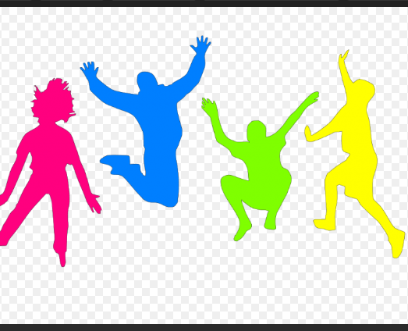  The year 5 teachers would love to see your videos so don’t forget to upload them onto Seesaw! | Watch Newsround  https://www.bbc.co.uk/newsround
Wednesday | You are Stanley! Write a diary entry about the day you were arrested. Reflect on the features of a diary before you start writing.  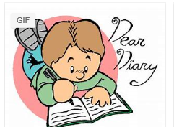 |  | Please make sure that you complete the work on accelerated maths today. Don’t forget to post your work on Seesaw! |  | RE:  Design a poster about Ramadan. Your poster can be designed for someone who is new to fasting, or for those that don’t know what Ramadan is.  Watch the video for more information:  https://www.bbc.co.uk/bitesize/topics/zpdtsbk/articles/zjc2bdm | Join Joe Wicks for his morning workout! | You can read about today’s top stories.  https://live.firstnews.co.uk/
Thursday | SPAG  Watch the video which shows you how to use apostrophes correctly and complete the activities.  https://www.bbc.co.uk/bitesize/articles/zdsthbk  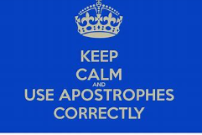 |  | Complete Week 5 (w/c 18th May) lessons on White Rose hub resources. Watch the teaching video first.  https://whiterosemaths.com/homelearning/year-5/ |  | History:  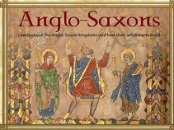  Over the next few weeks, you will be learning about the Anglo Saxons.  Watch the video and read to learn more.  https://www.bbc.co.uk/bitesize/topics/zxsbcdm/articles/zq2m6sg  Write 6 facts that you have learnt about the Anglo Saxons. | Complete the Theory activity on ‘joints in the body’ | ART:  Join the World Record Attempt to have the largest ever art lesson hosted by the famous author today between 4:00-4:30pm.  Register at www.artworldrecords.com  Your teachers will be taking part!  See the letter on the home learning page.
Friday | Watch the video which explains what a modal verb is and then complete the quiz.  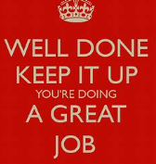  https://www.bbc.co.uk/bitesize/topics/z4hrt39/articles/zfbyb82 |  | Complete Week 5 (w/c 18th May) lessons on White Rose hub resources. Watch the teaching video first.  https://whiterosemaths.com/homelearning/year-5/ |  | DT:  A Balanced Diet:  Learn about food groups and why a balanced diet is important for both children and adults.  https://www.bbc.co.uk/bitesize/topics/zrffr82/articles/zppvv4j  Think about the food a toddler might eat compared to an adult athlete. Choose five different types of people (e.g. a child, teenager, athlete, teacher etc.) and draw a plate of food that will ensure they are eating a healthy, balanced diet. Underneath each plate, you must justify why you have chosen these foods. Think about the calorie intake each of these individuals might need. Can some people have more of one type of food group? If yes, why can they? | Joe Wicks daily workout or Martial arts wake up shake up with Jack.  (YouTube) | Story time Here are some FREE audiobooks. Everything from Harry Potter to Frankenstein!  https://stories.audible.com/discovery

