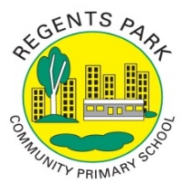
Regents Park Community Primary School
Home Learning 2019 – 2020
Week 12: 29.06.2020
*All work needs to be put onto Seesaw!*

Week beginning: | English including SPaG |  | Maths |  | Topic including Spanish | PE including Outdoor Learning | Reading for Pleasure
Monday | Watch this video to learn about how to use apostrophes in contractions.  https://www.bbc.co.uk/bitesize/topics/zvwwxnb/articles/zcyv4qt  Read the information and complete all the activities. |  | Practise your times tables using Time Table Rockstars  Make sure you are practising for the year 5 and 6 TTRS competition! |  | ART  Go onto Rob’s website and select video 5 –Alien. Make sure you have a pencil and paper ready; watch the video and follow the step-by-step instructions.  http://www.robbiddulph.com/draw-with-rob  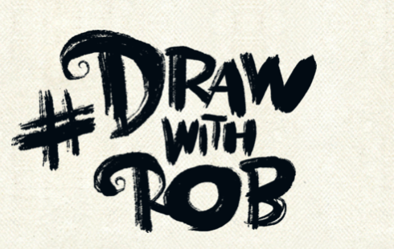 | Join Joe Wicks for his morning workout! | Story time Here are some FREE audiobooks. Everything from Harry Potter to Frankenstein!  https://stories.audible.com/discovery
Tuesday | https://www.bbc.co.uk/bitesize/articles/zqhn7yc  Read the introduction on Shakespeare’s life. Watch the video.  Write down 5 facts you have learnt about him. |  | Complete Week 12 (w/c 29th June) lessons on White Rose hub resources. Watch the teaching video first.  https://whiterosemaths.com/homelearning/year-5/  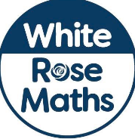 |  | P4C  What makes you,  you? | PE Home challenge 1  https://www.rgntpark.bham.sch.uk/at-home-challenges-1/ | Watch Newsround  https://www.bbc.co.uk/newsround
Wednesday | https://www.bbc.co.uk/bitesize/articles/zqhn7yc  Recap on the life of Shakespeare by watching the video again from yesterday. Complete Activity 1 – ordering events from Shakespeare’s life. |  | Please make sure that you complete the work on accelerated maths today. Don’t forget to post your work on Seesaw! |  | SCIENCE  LIFE CYCLES IN HUMANS AND ANIMALS  https://www.bbc.co.uk/bitesize/articles/zjppf4j  Watch the video and read the information. Order the life cycle of a butterfly and chicken. | Join Joe Wicks for his morning workout! | Story time Here are some FREE audiobooks. Everything from Harry Potter to Frankenstein!  https://stories.audible.com/discovery
Thursday | https://www.bbc.co.uk/bitesize/articles/zqhn7yc  Read the information and watch the clip about ‘The Twelfth Night’  Do Activity 2. |  | Complete Week 12 (w/c 29th June) lessons on White Rose hub resources. Watch the teaching video first.  https://whiterosemaths.com/homelearning/year-5/ |  | SCIENCE  Human Life cycle.  https://www.bbc.co.uk/bitesize/articles/zjppf4j  Watch the video, read the information and order the pictures. | PE home challenge 2  https://www.rgntpark.bham.sch.uk/at-home-challenges-1/ | Watch Newsround  https://www.bbc.co.uk/newsround
Friday | https://www.bbc.co.uk/bitesize/articles/zqhn7yc  Challenge yourself! Have a go at  SUPER CHALLENGE |  | Complete Week 12 (w/c 29th June) lessons on White Rose hub resources. Watch the teaching video first.  https://whiterosemaths.com/homelearning/year-5/ |  | DT  Cooking  Different cultures have different food. Make a dish from your culture that you really enjoy eating.  Challenge: Upload your video of you making the dish. | Join Joe Wicks for his morning workout! | Think back to the part you have read of ‘Twelfth Night’  Write a paragraph to summarise your first impressions of the book.

