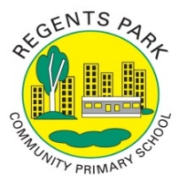
Regents Park Community Primary School
Home Learning 2019 – 2020
Week 14: 13.07.2020
*All work needs to be put onto Seesaw!*

Week beginning: | English including SPaG |  | Maths |  | Topic including Spanish | PE including Outdoor Learning | Reading for Pleasure
Monday | Watch this video to learn about how to use inverted commas.  https://www.bbc.co.uk/bitesize/topics/zvwwxnb/articles/ztcp97h  Read the information and complete all the activities. |  | Practise your times tables using Time Table Rockstars  Make sure you are practising for the year 5 and 6 TTRS competition! |  | ART  Go onto Rob’s website and select video 30 –Gorilla. Make sure you have a pencil and paper ready; watch the video and follow the step-by-step instructions.  http://www.robbiddulph.com/draw-with-rob  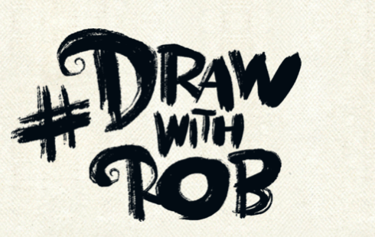 | Join Joe Wicks for his morning workout! | Story time Here are some FREE audiobooks. Everything from Harry Potter to Frankenstein!  https://stories.audible.com/discovery
Tuesday | https://www.bbc.co.uk/bitesize/articles/zjkgn9q  Read more information about William Shakespeare. Watch the video.  Using what you have learnt over the past few weeks about him, create a fact file. |  | Complete Week 14 (w/c 13th July) lessons on White Rose hub resources. Watch the teaching video first.  https://whiterosemaths.com/homelearning/year-5/  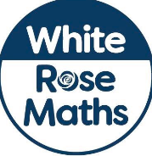 |  | P4C  How do you think talking helps you learn? | PE Home challenge 1  https://www.rgntpark.bham.sch.uk/at-home-challenges-1/ | Watch Newsround  https://www.bbc.co.uk/newsround
Wednesday | https://www.bbc.co.uk/bitesize/articles/zjkgn9q  Watch the video – Romeo and Juliet. Then read the summary.  Complete Activity 2. Write an alternative ending to the story. |  | Please make sure that you complete the work on accelerated maths today. Don’t forget to post your work on Seesaw! |  | SCIENCE  Solar System  https://www.bbc.co.uk/bitesize/articles/zhk2mfr  Read the information and complete Activity 1. | Join Joe Wicks for his morning workout! | Story time Here are some FREE audiobooks. Everything from Harry Potter to Frankenstein!  https://stories.audible.com/discovery
Thursday | https://www.bbc.co.uk/bitesize/articles/zjkgn9q  Write your ending as a play. |  | Complete Week 14 (w/c 13th July) lessons on White Rose hub resources. Watch the teaching video first.  https://whiterosemaths.com/homelearning/year-5/ |  | SCIENCE  https://www.bbc.co.uk/bitesize/articles/zhk2mfr  Go back and recap on planet Earth facts. Complete Activity 2. | PE home challenge 2  https://www.rgntpark.bham.sch.uk/at-home-challenges-1/ | Watch Newsround  https://www.bbc.co.uk/newsround
Friday | https://www.bbc.co.uk/bitesize/articles/zjkgn9q  Complete activity 3. Create a comic strip of the story of Romeo and Juliet. |  | Complete Week 14 (w/c 13th July) lessons on White Rose hub resources. Watch the teaching video first.  https://whiterosemaths.com/homelearning/year-5/ |  | DT  Design Skills  https://www.bbc.co.uk/bitesize/articles/zd6rkxs | Join Joe Wicks for his morning workout! | Think back to the part you have read of ‘Twelfth Night’  Write a paragraph to summarise your first impressions of the book.

