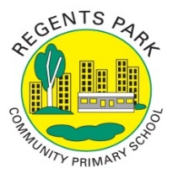
Regents Park Community Primary School
Home Learning 2019 – 2020
Week 9: 08.06.2020
*All work needs to be put onto Seesaw!*

Week beginning: | English including SPaG |  | Maths |  | Topic including Spanish | PE including Outdoor Learning | Reading for Pleasure
Monday | Watch this video to learn about how to use commas accurately and then complete the quiz.  https://www.bbc.co.uk/bitesize/topics/zvwwxnb/articles/zc773k7 |  | Practise your times tables using time table rockstars  Make sure you are practising for the year 5 and 6 TTRS competition! |  | ART  Go onto Rob’s website and select video 9 -self-portrait. Made sure you have a pencil and paper ready; watch the video and follow the step-by-step instructions to draw the perfect portrait.  http://www.robbiddulph.com/draw-with-rob  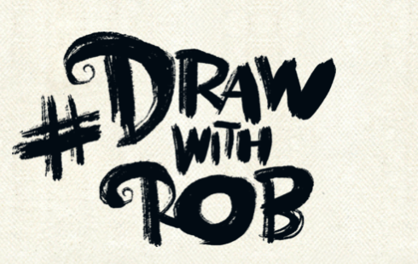 | Join Joe Wicks for his morning workout! | Story time Here are some FREE audiobooks. Everything from Harry Potter to Frankenstein!  https://stories.audible.com/discovery
Tuesday | Read chapter 8 and 9 of Holes and answer the following questions.  - Why is it significant that the author tells us that yellow-spotted lizards like to eat the shells of sunflower seeds? (page 42)  - Why was there no drain on the floor of the shower to catch all the water?  - What did Stanley do to make sure his mum wouldn’t worry about him?  - Find evidence from chapter 9 that shows that X-ray, Armpit and Squid like and respect Stanley.  - What does the word ‘intensity’ mean on page 47? |  | Complete Week 7 (w/c 8th June) lessons on White Rose hub resources. Watch the teaching video first.  https://whiterosemaths.com/homelearning/year-5/  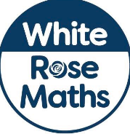 |  | P4C  Watch the video and answer the questions.  Is there a moral to this story? What do you think is happening? Can you think of a question that can be discussed with the class .  https://www.youtube.com/watch?v=WjoDEQqyTig&list=PL7kuX1o5eWLHqaID1-a_AidjrCfBTgTWK | Join Joe Wicks for his morning workout! | Watch Newsround  https://www.bbc.co.uk/newsround
Wednesday | Write a prediction of what you think will happen next based on what you have read so far.  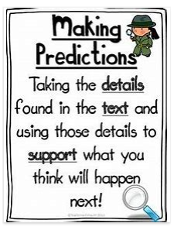 |  | Please make sure that you complete the work on accelerated maths today. Don’t forget to post your work on Seesaw! |  | SCIENCE  Forces  Watch this video to find out what a force is.  https://www.bbc.co.uk/bitesize/topics/zvpp34j/articles/zywcrdm  Write a few sentences to explain what a force is in your own words. Give some examples to demonstrate your understanding. | Join Joe Wicks for his morning workout! | You can read about today’s top stories.  https://live.firstnews.co.uk/
Thursday | Comprehension  Read the text ‘Big Ben gets a bath’ and answer the questions  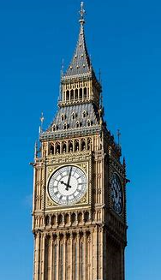 |  | Complete Week 7 (w/c 8th June) lessons on White Rose hub resources. Watch the teaching video first.  https://whiterosemaths.com/homelearning/year-5/ |  | SCIENCE  Friction  Follow the link to learn about friction and have a go at the quiz.  https://www.bbc.co.uk/bitesize/topics/zsxxsbk/articles/zxqrdxs | Join Joe Wicks for his morning workout! | Story time Here are some FREE audiobooks. Everything from Harry Potter to Frankenstein!  https://stories.audible.com/discovery
Friday | Choose your favourite character from the book Holes. Then using evidence from the text, explain why you selected the character.  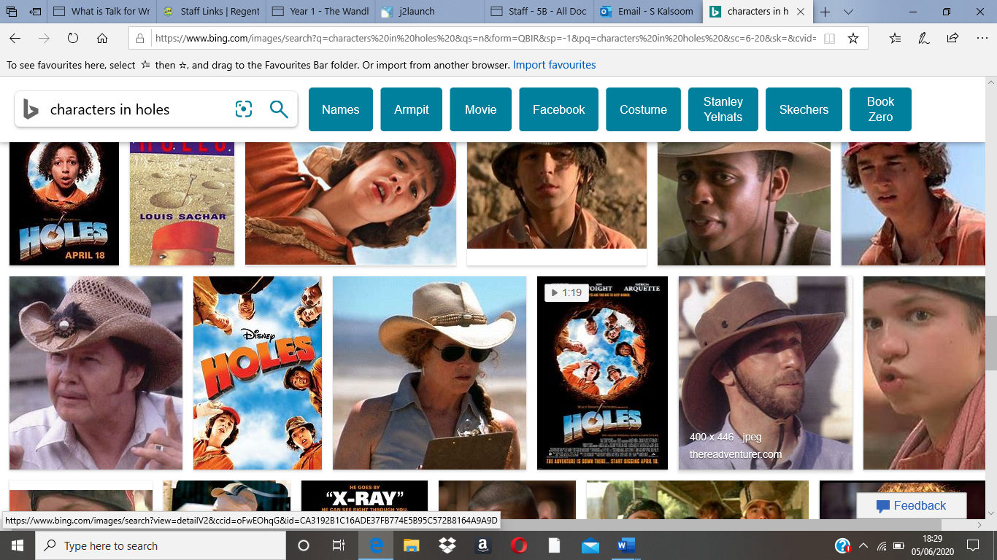 |  | Complete Week 6 (w/c 8th June) lessons on White Rose hub resources. Watch the teaching video first.  https://whiterosemaths.com/homelearning/year-5/ |  | MUSIC  Can you make a musical instrument using objects from your home? It can be as simple as just filling an empty bottle with some rice and shaking it to create music or you can be creative and use this website for some inspiration.  https://arts.onehowto.com/article/how-to-make-musical-instruments-at-home-334.html  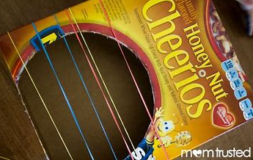 | Joe Wicks daily workout or Martial arts wake up shake up with Jack.  (YouTube) | Story time Here are some FREE audiobooks. Everything from Harry Potter to Frankenstein!  https://stories.audible.com/discovery

