
Regents Park Community Primary School
Home Learning 2019 – 2020
Week 2: 6th April 2020

Week beginning: | English including SPaG |  | Maths |  | Topic including Spanish | PE including Outdoor Learning | Reading for Pleasure
Monday | SPAG: Choose 5 year 5 or 6/3 or 4 spelling words. Write the meaning and write examples of sentences with these words.  Interview a family member to find out the following:  - Where were they born?  - Facts about their education.  - What things have they achieved in their life? |  | Complete week 2 lessons on White Rose hub resources  https://whiterosemaths.com/homelearning/year-5/  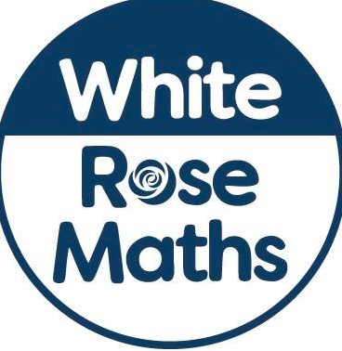 |  | Design and technology  Follow some simple recipes at home to create dishes with Jamie Oliver. It would be great to see some example of your food on twitter #kidscancook2020  https://www.jamieoliver.com/features/category/get-kids-cooking/ | Joe Wicks daily workout  (YouTube) | Story time  https://www.worldofdavidwalliams.com/tag/reading/  Listen to David Walliams read a novel each day.
Tuesday | SPAG: Write an acrostic poem using any of your spelling words.  Write a biography about the family member you interviewed yesterday. |  | Complete week 2 lessons on White Rose hub resources  https://whiterosemaths.com/homelearning/year-5/ |  | Design and technology  Imagine you are a food critic. Write a short review about what you have cooked. | Joe Wicks daily workout  (YouTube) | Story time  https://www.worldofdavidwalliams.com/tag/reading/  Listen to David Walliams read a novel each day.
Wednesday | SPAG: write as many words as you can using the letters given on https://www.puzzle-words.com/boggle-4x4/  Create a persuasive leaflet about a landmark in Birmingham for example, the Bullring, Cadbury world or Drayton Manor. |  | Complete your Star Maths Activities |  | Geography  - Write a list of as many countries as you can in Africa.  - How many capital cities can you name in the world?  - Write a list of the seas and oceans in the world. | Joe Wicks daily workout  (YouTube) | Story time using Free Accelerated Reader Books  https://www.getepic.com/collection/87539/accelerated-reader-level-20-29
Thursday | SPAG: Handwriting  Invent a character for a short story and write a character description. |  | Complete week 2 lessons on White Rose hub resources  https://whiterosemaths.com/homelearning/year-5/ |  | Science  Create a poster about washing your hands correctly which can be displayed in your home. | Joe Wicks daily workout  (YouTube) | Story time using Free Accelerated Reader Books  https://www.getepic.com/collection/87539/accelerated-reader-level-20-29
Friday | SPAG: Handwriting  Write a setting description for your short story. |  | Complete week 2 lessons on White Rose hub resources  https://whiterosemaths.com/homelearning/year-5/ |  | Music  Follow a music session with Myleene Klass  https://www.youtube.com/watch?v=R_zplGaphG8 | Joe Wicks daily workout  (YouTube) | Story time using Free Accelerated Reader Books  https://www.getepic.com/collection/87539/accelerated-reader-level-20-29

