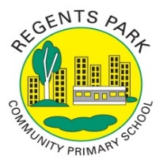
Regents Park Community Primary School
Home Learning 2019 – 2020
Week 6: 11.05.2020
*All work needs to be put onto Seesaw.*

Week beginning: | English including SPaG |  | Maths |  | Topic including Spanish | PE including Outdoor Learning | Reading for Pleasure
Monday | Why do you think Stanley has been sent to Camp Greenlake?  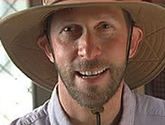 |  | Practise your times tables using time table rockstars  Make sure you are practising for the year 5 and 6 TTRS competition! |  | Art:  Observational drawing. Take a pencil and paper and draw someone or something using your observational skills.  And/Or  BECOME AN ARTS AMBASSADOR:  Do you love art?  Do you want to be a leader?  Apply to be the year group arts ambassador. It is like being a school councillor but focussing on art!  Find the application letter on this week’s home learning page! | Joe Wicks daily workout  (YouTube) | Story time Here are some FREE audiobooks. Everything from Harry Potter to Frankenstein!  https://stories.audible.com/discovery
Tuesday | Complete the comprehension for chapter 5, read by Mr Little.  - Why does Stanley think it would be pointless to tell Mr Pendanski that he is innocent?  - What are the names of the other boys in his tent?  - Why does Stanley feel uncomfortable sleeping in a bunk once owned by a boy called ‘Barf Bag’? |  | Complete Week 4 (w/c 11th May) lessons on White Rose hub resources. Watch the teaching video first.  https://whiterosemaths.com/homelearning/year-5/  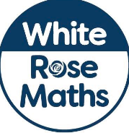 |  | Art:  Watch this video:  https://www.youtube.com/watch?v=LtvGQ-Izk-8  Have a go drawing some of the designs. Can you create your own design using your hand? | Video challenge: shoot a video of you doing your favourite exercise and challenge your friends to have a go.   | Watch Newsround  https://www.bbc.co.uk/newsround
Wednesday | Choose a character that you have read about at Camp Green Lake. Write a character description focussing on their appearance and how they behave. |  | Complete Week 4 (w/c 11th May) lessons on White Rose hub resources. Watch the teaching video first.  https://whiterosemaths.com/homelearning/year-5/ |  | Science:  Watch these 5 videos on the digestive system (don’t worry they’re all pretty short).  https://www.bbc.co.uk/bitesize/topics/z27kng8  Complete the word gaps at the end of each video. | Challenge:  How many jumping jacks can you do in a minute?  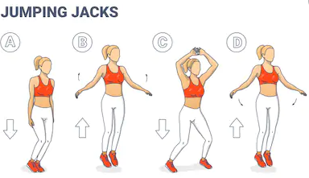 | You can read about today’s top stories.  https://live.firstnews.co.uk/
Thursday | Write a letter to your teacher telling them what you want to do when you get back to school. |  | Complete Week 4 (w/c 11th May) lessons on White Rose hub resources. Watch the teaching video first.  https://whiterosemaths.com/homelearning/year-5/ |  | P4C  What's the difference between grown ups and children?  Make a video discussing your ideas. You could even ask your parents to be in the video and share their ideas. | Keep Up Challenge:  Grab a ball, balloon, pillow… (it really does not matter)  How many keep ups can you do? You can use your hand, foot, head or whatever you like!   | Story time Here are some FREE audiobooks. Everything from Harry Potter to Frankenstein!  https://stories.audible.com/discovery
Friday | Imagine: If you were Boris Johnson (the Prime Minister of Britain), what would be the first thing you would do? Explain your answer. |  | Complete Week 4 (w/c 11th May) lessons on White Rose hub resources. Watch the teaching video first.  https://whiterosemaths.com/homelearning/year-5/ |  | PSHE: Write a healthy recipe that you like cooking or eating at home. Challenge: take a picture of the food and have it tweeted on the Regents Park Twitter account.   | Joe Wicks daily workout  (YouTube) | Story time Here are some FREE audiobooks. Everything from Harry Potter to Frankenstein!  https://stories.audible.com/discovery

