
Regents Park Community Primary School
Home Learning 2019 – 2020
Week 5: 04.05.2020
*All work needs to be put onto Seesaw.*

Week beginning: | English including SPaG |  | Maths |  | Topic including Spanish | PE including Outdoor Learning | Reading for Pleasure
Monday | Read chapter 1 - 4 of Holes.  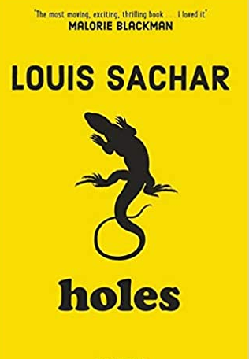 |  | Complete Week 3 (w/c 4th May) lessons on White Rose hub resources  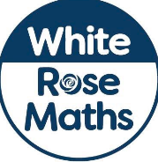  https://whiterosemaths.com/homelearning/year-5/ |  | VE Day:  Enter this competition (the deadline is 6th May) to report on VE day. Follow the link and watch the video for clear instructions.  https://ve-vjday75.gov.uk/dan-snows-ve-day-challenge/ | Miss Carrick-Perks’ PE theory lesson.  https://www.rgntpark.bham.sch.uk/theory-activities-2/ | Newsround:  Watch the latest episode of Newsround
Tuesday | Draw what you think Camp Greenlake would look like. Take a picture and upload it on Seesaw. |  | Complete Week 3 (w/c 4th May) lessons on White Rose hub resources  https://whiterosemaths.com/homelearning/year-5/  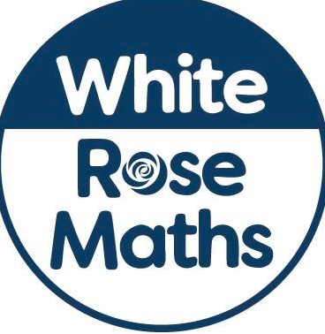 |  | History  Watch these videos about people’s stories from the war. What question would you ask them if you could?  https://ve-vjday75.gov.uk/veterans_stories/ | Joe Wicks daily workout  (YouTube) | Newsround  Watch the latest episode of Newsround.
Wednesday | Use the picture you have drawn. Write a description of what you can see. Focus on expanded noun phrases for description. |  | Complete your Star Maths Activities |  | Geography  Time zones: Follow the link to learn about time zones and complete the quiz.  Challenge: If it is 9 am (in the morning) in Birmingham, what is the time in Beijing?  https://www.bbc.co.uk/bitesize/topics/zvsfr82/articles/zjk46v4 | Joe Wicks daily workout  (YouTube) | Story time Here are some FREE audiobooks. Everything from Harry Potter to Frankenstein!  https://stories.audible.com/discovery
Thursday | Read chapter 5. Write a letter home to Stanley’s mum telling her about your first day. |  | Complete Week 3 (w/c 4th May) lessons on White Rose hub resources  https://whiterosemaths.com/homelearning/year-5/ |  | P4C  Do you always learn your lesson from a punishment?  Think of two main points and upload a video to Seesaw. | Joe Wicks daily workout  (YouTube) | Story time Here are some FREE audiobooks. Everything from Harry Potter to Frankenstein!  https://stories.audible.com/discovery
Friday | Why do you think Stanley has been sent to Camp Greenlake? |  | Complete Week 3 (w/c 4th May) lessons on White Rose hub resources  https://whiterosemaths.com/homelearning/year-5/ |  | Art:  Observational drawing. Take a pencil and paper and draw someone or something using your observational skills. | Joe Wicks daily workout  (YouTube) | Story time Here are some FREE audiobooks. Everything from Harry Potter to Frankenstein!  https://stories.audible.com/discovery

