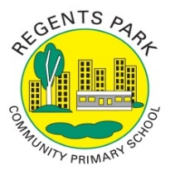
Regents Park Community Primary School
Home Learning 2019 – 2020
Week 4: 27th April 2020
*You do not have to print anything out to complete this. You can complete this work on blank paper.*

Week beginning: | English including SPaG |  | Maths |  | Topic including Spanish | PE including Outdoor Learning | Reading for Pleasure
Monday | SPAG: Choose 5 words ending in -ies (e.g. puppies, cities) and write two lines each of them in your neatest handwriting.  Write a list of people around the world who you think are worth celebrating. Explain your reasons why. |  | Complete Week 2 (w/c 27April) lessons on White Rose hub resources  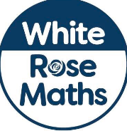  https://whiterosemaths.com/homelearning/year-5/ |  | Science Experiment  Baking soda volcano  You will need baking soda, vinegar and a container.  In this experiment, a chemical reaction between baking soda and vinegar creates a reaction.  As the reaction produces carbon dioxide gas, pressure builds up inside a plastic bottle until the gas bubbles and erupts. | Miss Carrick-Perks’ PE theory lesson.  https://regents-park-community-primary-school.secure-primarysite.net/theory-activities-2/ | Newsround:  Watch the latest episode of Newsround
Tuesday | SPAG: Use the 100 simple words sheet saved with this timetable. Choose 5 tier two words and use them in sentences.  Choose one of the people who you wrote about on Monday. Write a report about them. Challenge yourself by including one relative clause and one quotation. |  | Complete Week 2 (w/c 27April) lessons on White Rose hub resources  https://whiterosemaths.com/homelearning/year-5/  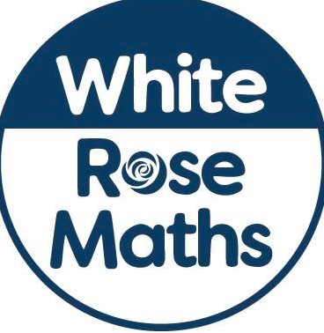 |  | Science  Report on the experiment. Try to use scientific language. | Joe Wicks daily workout  (YouTube) | Newsround  Watch the latest episode of Newsround.
Wednesday | SPAG: Have a go at this spelling game: https://www.topmarks.co.uk/english-games/7-11-years/spelling-and-grammar  Make a quiz about the person you have written about. Share it on Twitter #peopleworthcelebrating |  | Complete your Star Maths Activities |  | History  Watch these videos about Perseus and Medusa:  https://royalarmouries.org/home-learning-hub/home-learning-hub-ancient-greeks/ | Joe Wicks daily workout  (YouTube) | Story time Here are some FREE audiobooks. Everything from Harry Potter to Frankenstein!  https://stories.audible.com/discovery
Thursday | SPAG: Handwriting  Complete the following online quiz: https://www.educationquizzes.com/ks2/english/capital-letters-01/ |  | Complete Week 2 (w/c 27April) lessons on White Rose hub resources  https://whiterosemaths.com/homelearning/year-5/ |  | P4C  Birthdays should not be celebrated. Do you agree or disagree?  Try to convince someone in your family and use real -life examples to justify your opinion. | Joe Wicks daily workout  (YouTube) | Story time Here are some FREE audiobooks. Everything from Harry Potter to Frankenstein!  https://stories.audible.com/discovery
Friday | SPAG: Handwriting  Complete the following online quiz: https://www.educationquizzes.com/ks2/english/capital-letters-02/ |  | Complete Week 2 (w/c 27April) lessons on White Rose hub resources  https://whiterosemaths.com/homelearning/year-5/ |  | Music  Follow a music session with Myleene Klass  https://www.youtube.com/watch?v=a-nTQHM9fSg | Joe Wicks daily workout  (YouTube) | Story time Here are some FREE audiobooks. Everything from Harry Potter to Frankenstein!  https://stories.audible.com/discovery

