
Regents Park Community Primary School
Home Learning 2019 – 2020
Week 8: 01.06.2020
*All work needs to be put onto Seesaw!*

Week beginning: | English including SPaG |  | Maths |  | Topic including Spanish | PE including Outdoor Learning | Reading for Pleasure
Monday |  |  | See Activities on Seesaw!
Tuesday | Read chapter 7 up to the bottom of page 31 and the line, “He would have done it right then and there, but he wasn’t yet strong enough.”  Answer the following questions:  - What does the word ‘defective’ mean?  - Which boy had their own special shovel?  - Why did the dry lake bed remind Stanley of the moon?  - Why did it pay off for Stanley to be overweight?  - Where was Stanley’s grandfather born?  - What does Madame Zeroni offer Stanley? |  | Complete Week 6 (w/c 01st June) lessons on White Rose hub resources. Watch the teaching video first.  https://whiterosemaths.com/homelearning/year-5/  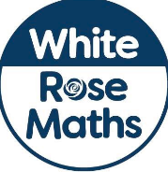 |  | Geography:  Choose a country that you have visited or interests you. Can you find five facts on that country?  You could mention the capital city, size of population or name of president or prime minister? | Join Joe Wicks for his morning workout! | Watch Newsround  https://www.bbc.co.uk/newsround
Wednesday | Read the remainder of chapter 7. On page 39, Elya sings a lullaby to his wife. Can you have a go writing your own lullaby?   |  | Please make sure that you complete the work on accelerated maths today. Don’t forget to post your work on Seesaw! |  | History:  Shield Wall!  Watch the following video and have a go making a shield wall:  https://royalarmouries.org/home-learning-hub/home-learning-hub-saxons/  Get your brothers and sisters to join in so that you can defend yourselves against Vikings.  Task: Can you write three tips to make sure your shield wall stays strong?  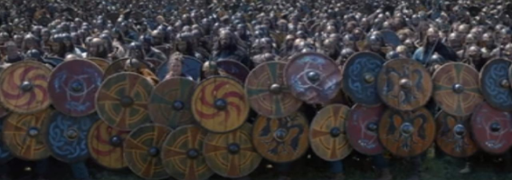 | Join Joe Wicks for his morning workout! | You can read about today’s top stories.  https://live.firstnews.co.uk/
Thursday | SPAG  Watch the video which shows you how to use synonyms and antonyms correctly and complete the activities.  https://www.bbc.co.uk/bitesize/articles/z6q48xs  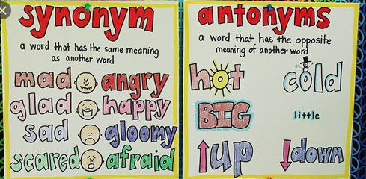 |  | Complete Week 6 (w/c 01st June) lessons on White Rose hub resources. Watch the teaching video first.  https://whiterosemaths.com/homelearning/year-5/ |  | History:  Anglo Saxons Beowulf part 1:  https://royalarmouries.org/home-learning-hub/home-learning-hub-saxons/  Have a go drawing what you think the monster Grendel looked like!  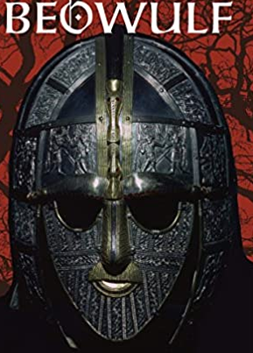  Have a go drwa | Join Joe Wicks for his morning workout! | Story time Here are some FREE audiobooks. Everything from Harry Potter to Frankenstein!  https://stories.audible.com/discovery
Friday | Choose a paragraph from chapter 7. Can you declaim (say out loud) the paragraph with as much feeling as possible?  Upload a film of yourself doing so. |  | Complete Week 6 (w/c 01st June) lessons on White Rose hub resources. Watch the teaching video first.  https://whiterosemaths.com/homelearning/year-5/ |  | DT:  Exercise plan: Create next week’s exercise plan!  We need a timetable with an activity (or two) for each day’s PE lesson.  It’s your turn to be Joe Wicks! | Joe Wicks daily workout or Martial arts wake up shake up with Jack.  (YouTube) | Story time Here are some FREE audiobooks. Everything from Harry Potter to Frankenstein!  https://stories.audible.com/discovery

