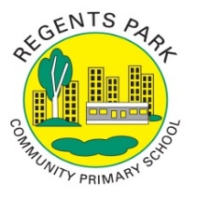
Regents Park Community Primary School
Home Learning 2019 – 2020
Week 11: 22.06.2020
*All work needs to be put onto Seesaw!*

Week beginning: | English including SPaG |  | Maths |  | Topic including Spanish | PE including Outdoor Learning | Reading for Pleasure
Monday | Watch the video to learn about different types of poems and their features.  https://www.bbc.co.uk/bitesize/articles/zmf8qnb  Read about the language used in poems and have a go at the quiz to demonstrate your understanding. |  | Practise your times tables using Time Table Rockstars  Make sure you are practising for the year 5 and 6 TTRS competition! |  | ART  Go onto Rob’s website and select a video of your choice. Make sure you have a pencil and paper ready; watch the video and follow the step-by-step instructions to create a fantastic drawing!  http://www.robbiddulph.com/draw-with-rob  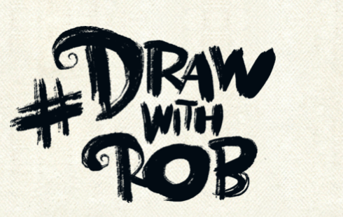 | Join Joe Wicks for his morning workout!  https://www.youtube.com/user/thebodycoach1 | Story time Here are some FREE audiobooks. Everything from Harry Potter to Frankenstein!  https://stories.audible.com/discovery
Tuesday | https://www.bbc.co.uk/bitesize/articles/zmf8qnb  Can you recall the different types of poems you learnt about yesterday?  Get your detective skills ready and analyse poems by completing activity two – this is a continuation of yesterday’s work.  Don’t forget to post a picture with your annotations. |  | Complete Week 11 (w/c 22nd June) lessons on White Rose hub resources. Watch the teaching video first.  https://whiterosemaths.com/homelearning/year-5/  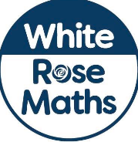 |  | P4C  What if adults never grew old…would that be a good thing or a bad thing? Why? | PE Home challenge 1  https://www.rgntpark.bham.sch.uk/at-home-challenges-1/ | Read one of these 25 short stories, written by 10-13 year olds whose stories have been shortlisted for the 500 Words story-writing competition.  https://www.bbc.co.uk/programmes/articles/JBXM0fk15pltYzBjlFH8mH/top-50-stories-2020-age-10-to-13
Wednesday | https://www.bbc.co.uk/bitesize/articles/z6n6dp3  Watch the video and read to learn more about figurative language.  Complete activity 1.  If you would like to challenge yourself further (and impress you teacher!) have a go at activity 3. Don’t forget to post it onto Seesaw! |  | Please make sure that you complete the work on accelerated maths today. Don’t forget to post your work on Seesaw! |  | SCIENCE  Floating and Sinking  Watch the video  https://www.bbc.co.uk/bitesize/topics/zc89k7h  Can you share some examples of what kind of things would float and which would sink? | Join Joe Wicks for his morning workout!  https://www.youtube.com/user/thebodycoach1 | Watch Newsround  https://www.bbc.co.uk/newsround
Thursday | Today you will look at how poems are performed.  https://www.bbc.co.uk/bitesize/articles/zmf8qnb  Can you identify the features of performing poems? Share your answers on Seesaw. |  | Complete Week 11 (w/c 22nd June) lessons on White Rose hub resources. Watch the teaching video first.  https://whiterosemaths.com/homelearning/year-5/ |  | SCIENCE  Design a poster about everything you have learnt about forces. You can revisit the BBC Bitesize website if you need a reminder. | PE home challenge 3  https://www.rgntpark.bham.sch.uk/at-home-challenges-1/ | Story time Here are some FREE audiobooks. Everything from Harry Potter to Frankenstein!  https://stories.audible.com/discovery
Friday | Use all the resources available to in the link below to write your very own nonsense poem. Share your written poems on Seesaw or even better record yourself performing the poem!  https://www.bbc.co.uk/bitesize/articles/zjt296f |  | Complete Week 11 (w/c 22nd June) lessons on White Rose hub resources. Watch the teaching video first.  https://whiterosemaths.com/homelearning/year-5/ |  | PSHE  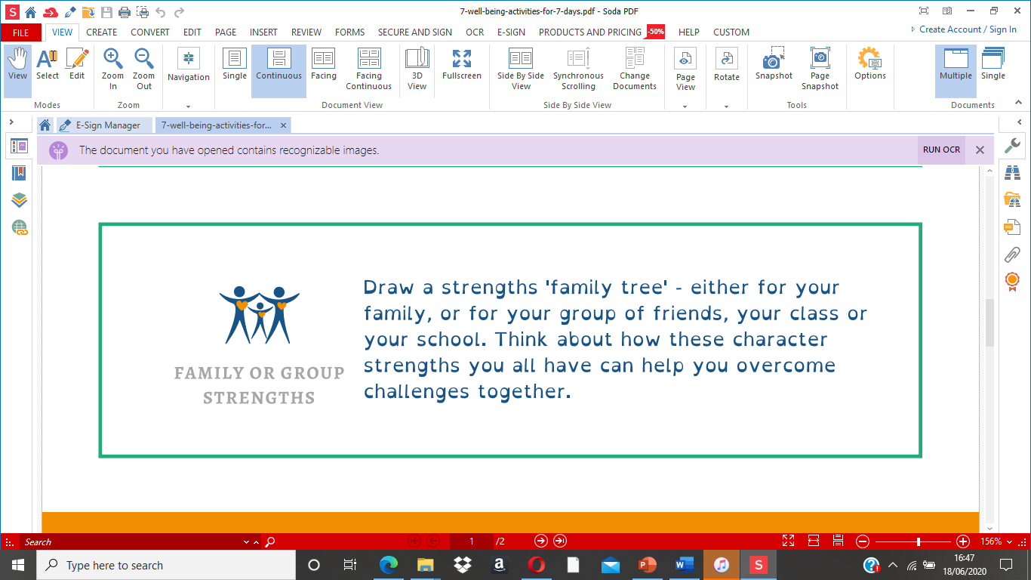 | Join Joe Wicks for his morning workout!  https://www.youtube.com/user/thebodycoach1 | Curl up with a book of your choice in a peaceful place in your house. We’d love to see your pictures so don’t forget to upload them onto Seesaw!

