
Regents Park Community Primary School
Home Learning 2019 – 2020
Week 13: 06.07.2020
*All work needs to be put onto Seesaw!*

Week beginning: | English including SPaG |  | Maths |  | Topic including Spanish | PE including Outdoor Learning | Reading for Pleasure
Monday | Watch this video to learn how to use imperative verbs to write instructions.  https://www.bbc.co.uk/bitesize/articles/zbxgn9q  complete activities 1 and 2. |  | Practise your times tables using Time Table Rockstars  Make sure you are practising for the year 5 and 6 TTRS competition! |  | ART  Go onto Rob’s website and select a video. Make sure you have a pencil and paper ready; watch the video and follow the step-by-step instructions.  http://www.robbiddulph.com/draw-with-rob  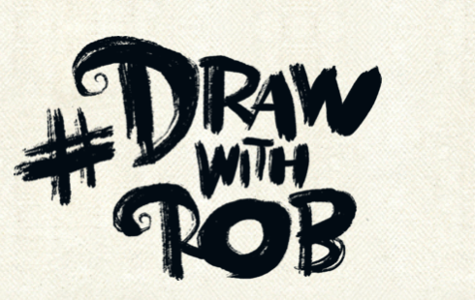 | Join Joe Wicks for his morning workout! | https://app.seesaw.me/pages/shared_activity?share_token=NHHWm1gaTBOw7xmHERAv-w&prompt_id=prompt.746e7f25-ca90-45b6-8313-d4ed04247efd  Take part in this book Quiz arranged by Mr Genner to win a fantastic Harry Potter Game!!!
Tuesday | https://www.bbc.co.uk/bitesize/articles/z9c9ydm  Using the play Macbeth you will learn how to summarise a character and use information from a text to write.  Watch the video and complete activity 1 by writing a paragraph describing the three witches. |  | Complete Week 13 (w/c 6th July) lessons on White Rose hub resources. Watch the teaching video first.  https://whiterosemaths.com/homelearning/year-5/  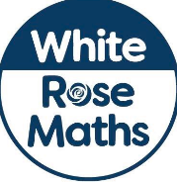 |  | P4C  What is true happiness? | PE Home challenge 3  https://www.rgntpark.bham.sch.uk/at-home-challenges-3/ | Watch Newsround  https://www.bbc.co.uk/newsround
Wednesday | https://www.bbc.co.uk/bitesize/articles/z9c9ydm  Complete activity 2. Remember to use your knowledge of PEE (Point, evidence, explain) to answer the questions. |  | Please make sure that you complete the work on accelerated maths today. Don’t forget to post your work on Seesaw! |  | SCIENCE  LIFE CYCLES IN HUMANS AND ANIMALS  https://www.bbc.co.uk/bitesize/articles/zjppf4j  Complete activity 1 and 2. | Join Joe Wicks for his morning workout! | Story time Here are some FREE audiobooks. Everything from Harry Potter to Frankenstein!  https://stories.audible.com/discovery
Thursday | https://www.bbc.co.uk/bitesize/articles/z9c9ydm  Write all or a part of the letter Macbeth writes to his wife. Read the top tips to help you. |  | Complete Week 13 (w/c 6th July) lessons on White Rose hub resources. Watch the teaching video first.  https://whiterosemaths.com/homelearning/year-5/ |  | SCIENCE  Human Life cycle.  https://www.bbc.co.uk/bitesize/articles/zjppf4j  Complete activity 3. | PE home challenge 4  https://www.rgntpark.bham.sch.uk/at-home-challenges-4/ | Watch Newsround  https://www.bbc.co.uk/newsround
Friday | https://www.bbc.co.uk/bitesize/articles/z9c9ydm  It would be great to see you record yourself reading the letter that you wrote yesterday! |  | Complete Week 13 (w/c 6th July) lessons on White Rose hub resources. Watch the teaching video first.  https://whiterosemaths.com/homelearning/year-5/ |  | DT  https://www.bbcgoodfood.com/recipes/rainbow-fruit-skewers  Can you have a go at making fruit stewers using the fruit you have at home? | Join Joe Wicks for his morning workout! | https://app.seesaw.me/pages/shared_activity?share_token=o6XAWqgGRne_L_kvRu_yqQ&prompt_id=prompt.6dcc6ce5-ca66-42c4-b556-7539e851421f  Watch the video of actresses Rachel Shenton and Maisie Sly give a fascinating and interactive introduction to BSL (British Sign Language)  Record yourself and upload the video on seesaw.

