
Regents Park Community Primary School
Home Learning 2019 – 2020
Week 10: 15.06.2020
*All work needs to be put onto Seesaw!*

Week beginning: | English including SPaG |  | Maths |  | Topic including Spanish | PE including Outdoor Learning | Reading for Pleasure
Monday | Watch this video to learn about how to use exclamation marks accurately and then complete the quiz.  https://www.bbc.co.uk/bitesize/topics/z8x6cj6/articles/z3dcmsg |  | Practise your times tables using Time Table Rockstars  Make sure you are practising for the year 5 and 6 TTRS competition! |  | ART  Go onto Rob’s website and select video 1 –Gregosau rus. Make sure you have a pencil and paper ready; watch the video and follow the step-by-step instructions.  http://www.robbiddulph.com/draw-with-rob  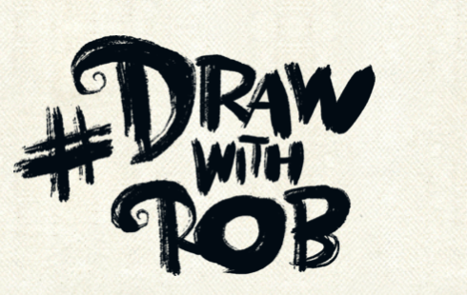 | Join Joe Wicks for his morning workout! | Story time Here are some FREE audiobooks. Everything from Harry Potter to Frankenstein!  https://stories.audible.com/discovery
Tuesday | https://www.bbc.co.uk/bitesize/articles/zd7dqp3  Read the introduction into book ‘The Wolves of Willoughby Chase’ by Joan Aiken.  Watch the first extract read by TV presenter.  - What impression do you get of Willoughby Chase?  - Why do you think wolves are mentioned?  - What do you notice about the techniques used for description in this extract? |  | Complete Week 8 (w/c 15th June) lessons on White Rose hub resources. Watch the teaching video first.  https://whiterosemaths.com/homelearning/year-5/  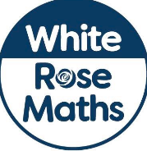 |  | P4C  If you had 1 wish, what would it be? Why? | PE Home challenge 1  https://www.rgntpark.bham.sch.uk/at-home-challenges-1/ | Watch the 1st extract again from ‘The Wolves of Willoughby Chase’  https://www.bbc.co.uk/bitesize/articles/zd7dqp3  What are your first impressions of the book? Has the extract brought up questions for you as the reader?
Wednesday | https://www.bbc.co.uk/bitesize/articles/zd7dqp3  Listen to the second extract.  What impression do you get of the relationship between Sir Willoughby and his daughter Bonnie? |  | Please make sure that you complete the work on accelerated maths today. Don’t forget to post your work on Seesaw! |  | SCIENCE  Water and Air Resistance  Watch the video  https://www.bbc.co.uk/bitesize/topics/zsxxsbk/articles/zxw6gdm  Complete the quiz. | Join Joe Wicks for his morning workout! | Watch Newsround  https://www.bbc.co.uk/newsround
Thursday | https://www.bbc.co.uk/bitesize/articles/zd7dqp3  Do Activity 1. Read the passage, make notes to describe the inside and the outside of the house and then use this information to write the next paragraph. |  | Complete Week 8 (w/c 15th June) lessons on White Rose hub resources. Watch the teaching video first.  https://whiterosemaths.com/homelearning/year-5/ |  | SCIENCE  Gravity  Watch the video  https://www.bbc.co.uk/bitesize/topics/zf66fg8/articles/zqbm3k7  Complete the fill in the gaps task. | PE home challenge 2  https://www.rgntpark.bham.sch.uk/at-home-challenges-1/ | Story time Here are some FREE audiobooks. Everything from Harry Potter to Frankenstein!  https://stories.audible.com/discovery
Friday | https://www.bbc.co.uk/bitesize/articles/zd7dqp3  Do Activity 2 – Direct speech and what this tells us about the characters. |  | Complete Week 8 (w/c 15th June) lessons on White Rose hub resources. Watch the teaching video first.  https://whiterosemaths.com/homelearning/year-5/ |  | PSHE  Mental Wellbeing activity based on Secrets. What is a safe secret and unsafe secret?  https://www.coramlifeeducation.org.uk/scarf/lesson-plans/dear-ash-1 | Join Joe Wicks for his morning workout! | Think back to the part you have read of ‘The Wolves of Willoughby Chase’  Write a paragraph to summarise your first impressions of the book.

