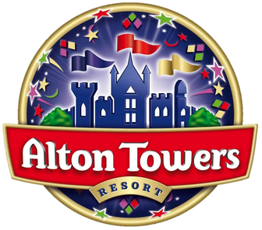  Are you bored and fed up of visiting the same boring places? Then head straight to Alton Towers theme park this summer, where you are guaranteed the time of your life! Alton Towers is a majestic 5 STAR adventure park which has captured the world’s imagination. Alton Towers is more than just a theme park, it's an entire universe of action and thrills! From the moment you arrive, you will be screaming at the top of your voice!  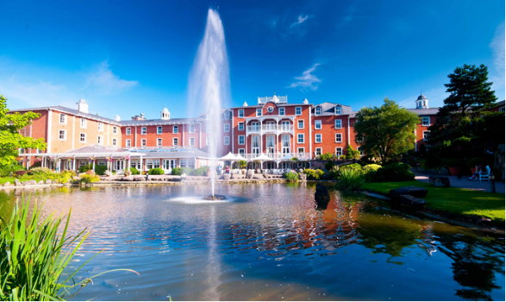 | Enter ALTON TOWERD and never want to leave!  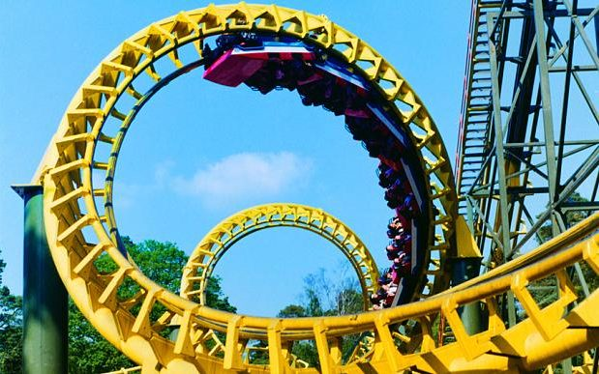  Twist, spin, flip, twirl and zoom around ferocious tracks, insanely high loops until the sun goes down. Experience flying on the smoothest ride in the world - Air. This stunning coaster twirls your around and simulates the flight of a bird drifting through the sky. The g-forces of Rita (Queen of Speed) will have you hurtling, twisting and turning as it reaches speeds of 100mph! | 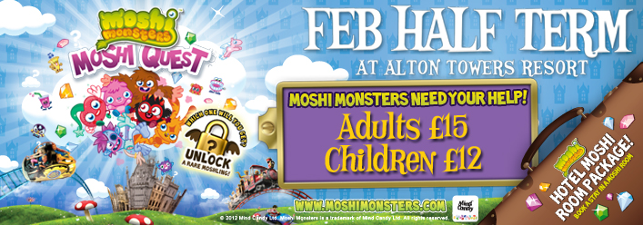  Whilst the adults fly around in mind boggling rides, there is plenty for young children to enjoy. Located deep in the heart of the theme park, is the magical world of CBeebies Land. Overall, Alton Towers is the number one choice for the entire family. There are thousands of options for you to choose from, including hair raising roller coasters, relaxing cafes and children’s entertainment. Plus, the Alton Towers Water Park will get you soaked if you fancy a day of aqua entertainment.  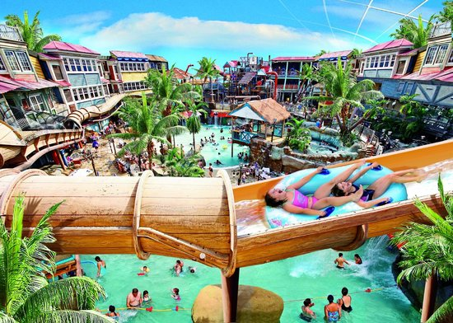  Visit – www.altontowers.com for more information and family deals!

