Fluency |  Fluency - problems |  reasoning and problem solving
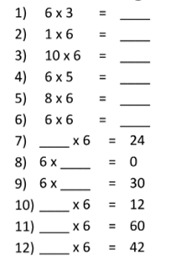  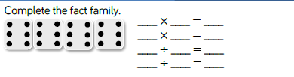 | 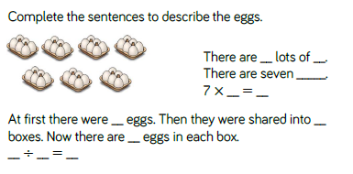  There are 9 baskets. Each has 6 apples. How many are there in total? Write a multiplication and division sentence to describe the word problem.  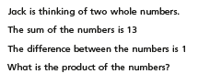 | 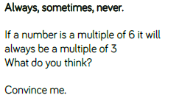  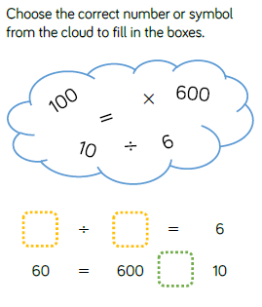
LO: To recall multiplication and division facts for the multiplication tables – six times tables

