Wednesday 30th September 2020
Activities
English –This week we are looking at poetry
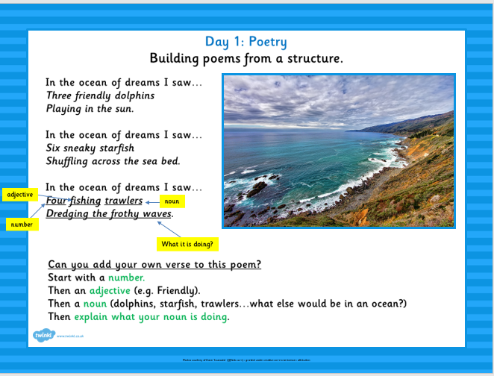
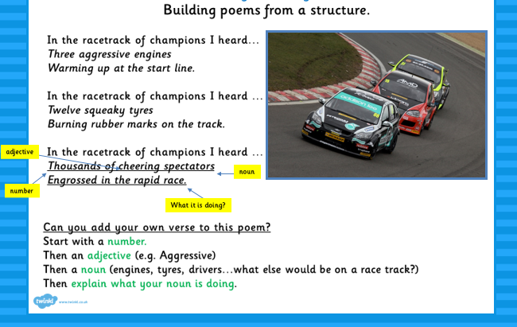

Handwriting:
Practise these patterns and joins on paper:
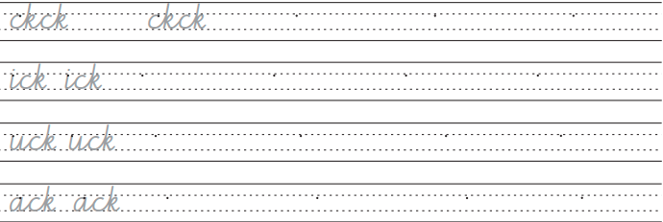
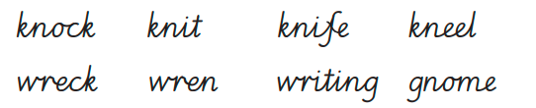

Maths:
Complete the additions sheet using the column method.
Science:
Read the information about The Plant lifecycle and then draw a poster explaining the process for children in Year 2

