

Reception
Week beginning: 6th April 2020 Easter
Weekly Maths Tasks (Aim to do 1 per day) | Weekly Reading Tasks (Aim to do 1 per day)
- Listen to the story Goldilocks and the Three Bears together. Then talk about the story. How many bears are there? Who is the biggest? Who is the smallest? Why did Goldilocks go to the Bears’ house?https://www.bbc.co.uk/cbeebies/watch/goldilocks-story  - Watch the Numberblocks episode Flatland about 2D shapes. https://www.bbc.co.uk/iplayer/episode/b0bp2qlb/numberblocks-series-3-flatland Which 2D shapes did you see? Go on a shape hunt around your house, use the checklist to help you.  - Use White Rose Maths https://whiterosemaths.com/homelearning/early-years/ and complete week 2 lessons and activities, this week it’s all about the story What the Ladybird Heard.  - Go on a number hunt around your house. What number do you live at? Which numbers can you see in the kitchen? Have a look out of the window, can you see any numbers?  - Have a go at drawing a castle, house or chicken using 2D Shapes. Have a look at the pictures below to help you. Can you name the shapes?  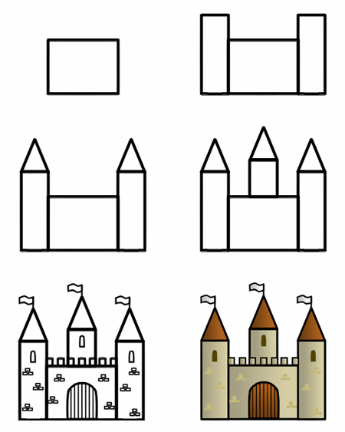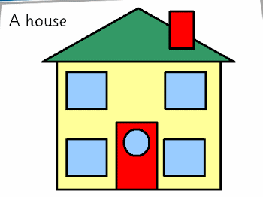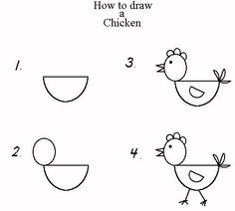 | - Listen to an audio book online. Click here to choose a story to listen to: https://stories.audible.com/start-listen  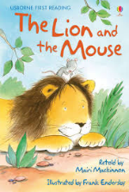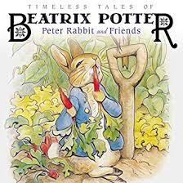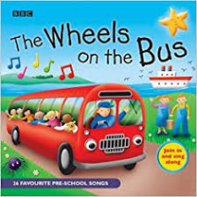  - With your child, look in magazines, newspapers and books for ‘tricky’ words they are currently learning. They could use a highlighter to highlight in magazines and newspapers.  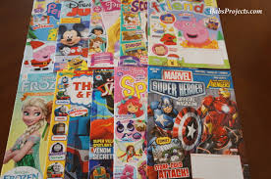  - Children to read to parents daily. Visit Bug club on our school website. Click here to log in:  https://www.activelearnprimary.co.uk/login?c=0  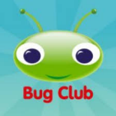  - Read a variety of books at home. Favourites can be repeated.  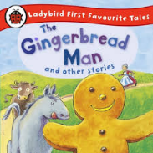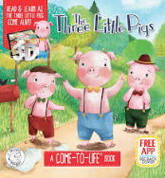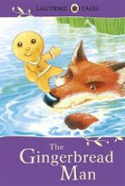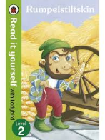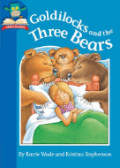  - Sing Nursery Rhymes and songs together. Add in actions and change the words. Children can think of different rhyming words to add in? Repeat old favourites and learn new rhymes.  Click here for Cbeebies Nursery rhymes to sing along to:  https://www.bbc.co.uk/cbeebies/curations/nursery-rhymes
Weekly Phonics Tasks (Aim to do 1 per day) | Weekly Writing Tasks (Aim to do 1 per day)
Can you read these digraphs?  sh ch oo ai ee  Can you think of a word that includes each phoneme?  Look around your house, can you spot any objects that begin with any of these phonemes?  j v w y z  Can you draw pictures of the objects and write labels for them?  Can you look in a book and find any of these words?  He she me be we my you all are they was.  Write down the words you found and the title of the book they were in.  Can you write a simple sentence about each of the following pictures?  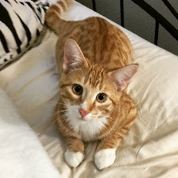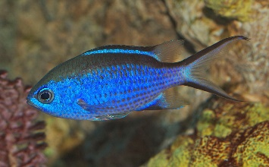  https://regents-park-community-primary-school.primarysite.media/  Follow this link and watch the video clip of Mrs Halton showing you some phonemes. Can you write the phonemes down? | - Practice letter formation, can your child form upper case and lower-case letters correctly.  - Sing the days of the week song  https://www.youtube.com/watch?v=mXMofxtDPUQ  Can your child create a food diary for the week. Talk about what they had for breakfast, lunch and dinner.  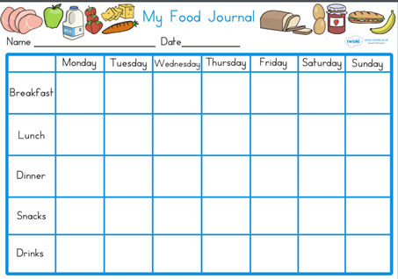  - Ask your child to draw and write a shopping list to help plan for the weekly shop. Encourage them to ask all family members views on what they would like to eat for the week.  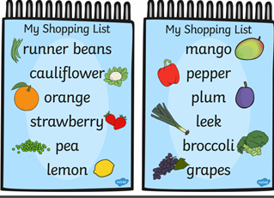  - Ask your child if you could create your own Easter egg, what would it be made out of? Think of words to describe it, is it shiny, big, tasty? Draw and write about it.  - Do some baking and make chocolate Easter nests with your child. Talk about the ingredients you will need to use and what happens throughout the baking process. Ask your child to write the recipe.  https://www.bbcgoodfood.com/recipes/shredded-wheat-nests

Learning Project - To be done throughout the week
Can you find out about Easter? Watch Cbeebies Let’s Celebrate and write down what you have learnt. https://www.bbc.co.uk/cbeebies/watch/lets-celebrate-easter. Who celebrates Easter? How do people celebrate Easter?

Can you design your own Easter egg? Use different colours and patterns. Have a look at the pictures for some ideas.
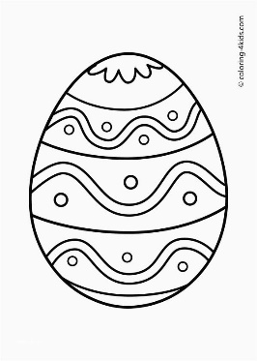i

PE and Outdoor learning
https://www.bing.com/videos/search?q=gonoodle&&view=detail&mid=1CC63AC19D008FA67C2A1CC63AC19D008FA67C2A&&FORM=VRDGAR&ru=%2Fvideos%2Fsearch%3Fq%3Dgonoodle%26FORM%3DHDRSC3
Follow this link which leads to a short dance/exercise to encourage children to get moving.
Explore go noodle activities website. You can find videos on you tube or can set up your own account which is free.

Create your own exercise routine:

Run on the spot for 1 minute
Do 10 star jumps.
Hop on one foot 10 times.
Stretch up as tall a s a giraffe.
Curl up in a ball like a hedgehog.

Make some eggs using junk modelling and hide them outside to create our own egg hunt!

