Year 5 Residential trip
Friday 8th November 2024
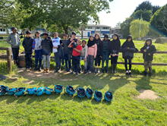

Dear Y5 Parents/Guardians

We are delighted to let you know about our Y5 school residential trip to Kingswood Activity Centre in Staffordshire. The three-day residential educational adventure activity course at the Kingswood Centre will take place from Wednesday 4th June 2025 to Friday 6th June 2025 and is open to all Year 5 children.

Going on an adventurous residential trip gives children the opportunity to undertake experiences they wouldn’t normally be able to, such as rock climbing, zip line, abseiling and bush craft as well as problem solving and teamwork activities.

It also often gives children their first experience of independence away from home where they will learn to take responsibility for themselves and for others.

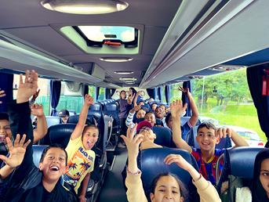
We believe that this is an exciting opportunity for your children and invite you to an information meeting on (Friday 15th November) where you can find out more about the exciting activities your child could take part in, menus for their stay, accommodation details, what to pack & overall cost.

Total cost is £70 per child or £50 for free school meal children. This would be £235 if not subsidised by the school.

If you would like to find out extra details about the ethos of Kingswood, their programmes and safety information. You can also visit www.kingswood.co.uk for more information.
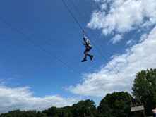
If you would like to secure a place, please send an email to the office enquiry@rgntpark.bham.sch.uk with your child’s name and class expressing an interest. Further details will follow.

Please note that there are 30 places for the residential and these will be allocated on a first come basis from the time and date we receive your email.

Please join us Friday 15th November for the parent information meeting in the Pe hall at 9.00am. Please sign in under the canopy outside of the hall.

Yours sincerely,
Mr Crawford
PE and Outdoor Learning Lead

