How can parents support what children are learning about rights at school?
- Take time to ask your child what he/she learned recently regarding children’s rights.
- Watch the news with your children and talk about the issues that may affect other children around the world.
- Discuss the ideas he/she is learning in class and try to think of examples from your own experiences, or from the media, of rights being respected or denied.
- Ask your child’s opinion on children’s rights.
- Remind your children about the differences between wants and needs.
- Look at the school websites for regular updates award our Rights Respecting schools award journey.
If you would like more information on Rights Respecting Schools, Please visit:
- http://www.unicef.org.uk/crc
- http://www.unicef.org.uk/rrsa
- http://www.rgntpark.bham.sch.uk/rights-respecting-schools-award/

ABCDE of Rights
At Regents Park, we follow the ABCDE of Rights rule to help us to remember why our rights as children are so important.
A: Rights are for ALL children across the world. They are universal.
B: Rights are there at BIRTH. They are inherent.
C: Rights CANNOT be taken away, given, bought or sold. They are inalienable.
D: Rights DO NOT have to be earnt. They are unconditional.
E: All rights are EQUALLY important. They are indivisible.
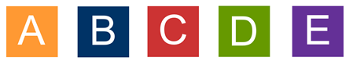

Our next Rights Respecting Day will be on the 3rd July 2019.

Rights Respecting Schools Award
United Nations Convention of Children’s rights
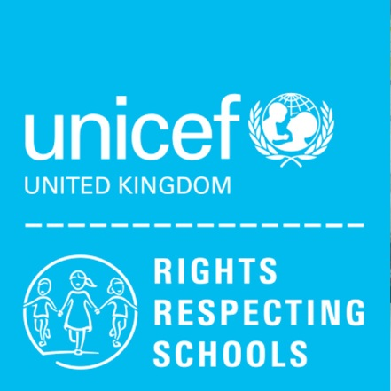

Regents Park Community school is proud to be a Rights Respecting School.

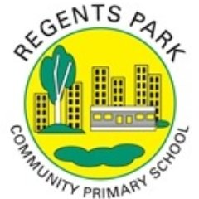
What is a Rights Respecting School?
At Regents Park, we believe that every child has equal rights and we respect the United Nations Conventions on the Rights of a child.
A Rights Respecting School promotes the United Nations Convention on the Rights of the Child (UNCRC).
Children have their own rights due to their vulnerability and need for protection. For children to reach their full potential these rights must be respected. All children have the same rights no matter where they live.
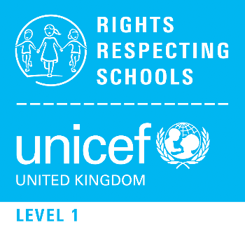
Children’s Rights at Regents Park community school.
Children’s rights are an integral part of our ethos and values at our school. They support our view that our children achieve most when they feel included and valued.
The school has achieved the bronze award and we are working towards achieving the UNICEF Rights Respecting School Silver Award, based on the UNCRC and we will be assessed for this on Wednesday 10th July 2019.
A Rights Respecting School is where:
- Pupils gain self esteem by learning about their rights
- Pupils learn that rights should be respected
- Pupils become active global citizens
- Pupils have a powerful voice.
Every class at Regents Park School have written a class charter which includes the rights that everyone in the class has agreed to. These can all be seen on the school website under the heading Parents>Rights Respecting Schools Award.

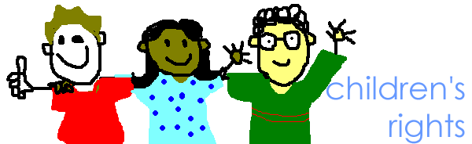
What does the United Nations Convention say on the Rights of the Child?
There are 54 articles that cover all aspects of a child’s life. It also explains how adults and governments must work together to make sure all children can enjoy all their rights. These are some of the rights we learn about.
Article 2- The Convention applies to every child without discrimination, whatever their ethnicity, gender, religion, language, abilities or any other status, whatever they think or say, whatever their family background.

Article 3- The best interests of the child must be a top priority in all decisions and actions that affect them.
Article 12- Every child has the right to express their views, feelings and wishes in all matters affecting them, and to have their views considered and taken seriously.

Article 13- Every child has the right to express their own opinion and have their voices heard.
Article 15- Every child has the right to meet with other children and join groups, as long as this does not stop other people from enjoying their rights.
Article 17- Every child right to reliable information from a variety of sources and the media should provide information that children can understand.
Article 28- Every child has the right to an education.
Article 30- Every child has the right to learn and use the language, customs and religion of their family, whether or not these are shared by the majority of the people in the country where they live.
Article 31- Every child has the right to play, relax and take part in a wide range of cultural activities.

