Article 31: Leisure, play and culture.
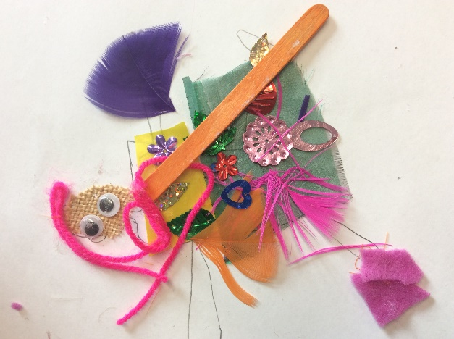
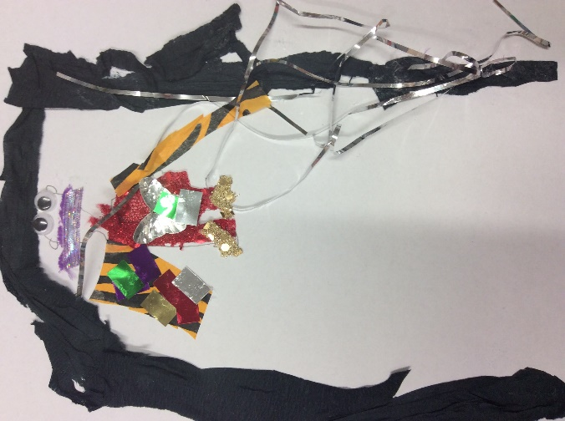
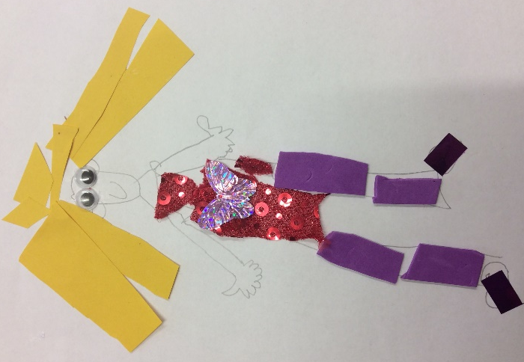
Article 13: Freedom of expression.
Children created artistic images of themselves using collage materials. They expressed themselves by showing how they look or would like to look.

