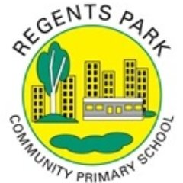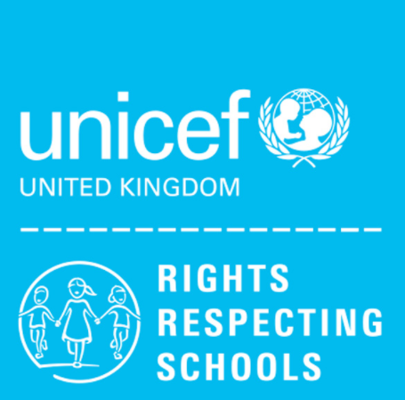
Class charter: 6G

1. Article 14 (freedom of thought, belief and religion) Every child has the right to think and believe what they choose and also to practise their religion, as long as they are not stopping other people from enjoying their rights. Governments must respect the rights and responsibilities of parents to guide their child as they grow up.

2. Article 28 (right to education) Every child has the right to an education. Primary education must be free and different forms of secondary education must be available to every child. Discipline in schools must respect children’s dignity and their rights. Richer countries must help poorer countries achieve this.

3. Article 31(leisure, play and culture) Every child has the right to relax, play and take part in a wide range of cultural and artistic activities.

