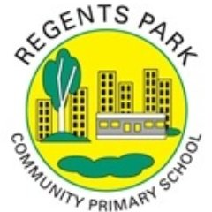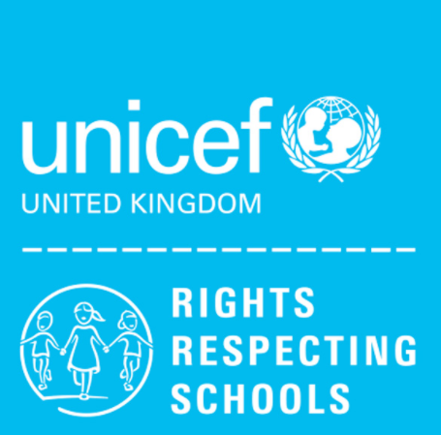
Class charter: 3N

Article 13 (freedom of expression) Every child must be free to express their thoughts and opinions and to access all kinds of information, as long as it is within the law.

Article 24 (health and health services) Every child has the right to the best possible health. Governments must provide good quality health care, clean water, nutritious food, and a clean environment and education on health and well-being so that children can stay healthy. Richer countries must help poorer countries achieve this.

Article 14 (freedom of thought, belief and religion) Every child has the right to think and believe what they choose and also to practise their religion, as long as they are not stopping other people from enjoying their rights. Governments must respect the rights and responsibilities of parents to guide their child as they grow up.

