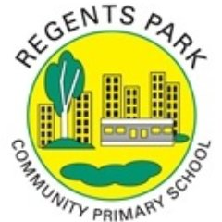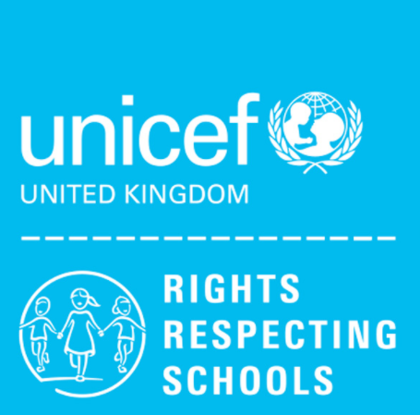
Class charter: 3W

- Article 13 (freedom of expression) Every child must be free to express their thoughts and opinions and to access all kinds of information, as long as it is within the law.

- Article 24 (health and health services) Every child has the right to the best possible health. Governments must provide good quality health care, clean water, nutritious food, and a clean environment and education on health and well-being so that children can stay healthy. Richer countries must help poorer countries achieve this.

- Article 31 (leisure, play and cultural) Every child has the right to relax, play and take part in a wide range of cultural and artistic activities

