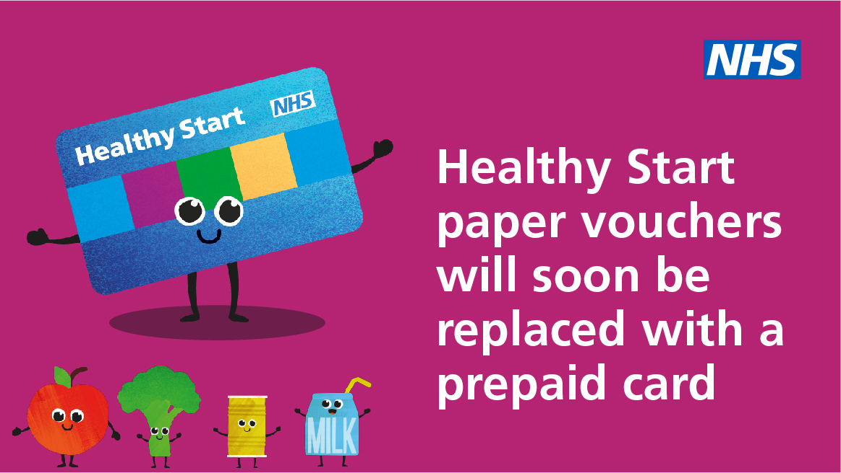

Apply online NOW

The Healthy Start scheme is changing, with a new online application process and prepaid card, to replace the paper vouchers. Paper vouchers will no longer be issued after 31st March 2022 so it is very important that you apply for a prepaid card as you will no longer receive vouchers after the 31st March 2022. You will not automatically be transferred onto the new scheme.

Please note that paper applications are no longer being accepted, if you do not have access to a computer or phone, ask your health visitor, midwife, Children Centre, or another organisation that you receive support from
To apply for the first time or get your new prepaid card, go to the Healthy Start website www.healthystart.nhs.uk/how-to-apply/ and follow the steps for applying.

Pregnant women and families with children under the age of 4 may be eligible for help to buy healthy food and milk if they are on certain benefits. Healthy Start vouchers are currently worth £4.25 per week per child under the age of four – but if you have a child under one year, you could get two vouchers a week giving you £8.50
Sign up online today – www.healthystart.nhs.uk/how-to-apply/

