Year Two Maths Organiser
  Doubles |  |  | Halves |  |  | Bonds To 20
  11 | 22 |  | 22 | 11 |  | 0 | 20
  12 | 24 |  | 24 | 12 |  | 1 | 19
  13 | 26 |  | 26 | 13 |  | 2 | 18
  14 | 28 |  | 28 | 14 |  | 3 | 17
  15 | 30 |  | 30 | 15 |  | 4 | 16
  16 | 32 |  | 32 | 16 |  | 5 | 15
  17 | 34 |  | 34 | 17 |  | 6 | 14
  18 | 36 |  | 36 | 18 |  | 7 | 13
  19 | 38 |  | 38 | 19 |  | 8 | 12
  20 | 40 |  | 40 | 20 |  | 9 | 11
   |  |  |  |  |  | 10 | 10
  Bonds Up To 20
  19 = 0 + 19  19 = 1 + 18  19 = 2 + 17  19 = 3 + 16  19 = 4 + 15 | 19 = 5 + 14  19 = 6 + 13  19 = 7 + 12  19 = 8 + 11  19 = 9 + 10
  Derived Facts
  
  
  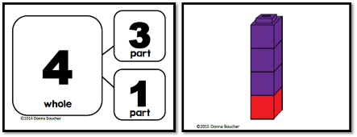
  Whole
  Part
  Part
  part + part = whole  part + part = whole  whole = part + part  whole = part + part  whole - part = part  whole - part = part  part = whole - part  part = whole - part | 3 + 1 = 4  1 + 3 = 4  4 = 3 + 1  4 = 1 + 3  4 - 3 = 1  4 - 1 = 3  1 = 4 - 3  3 = 4 - 1
  Fractions
  one half
  one third
  two thirds
  one quarter
  three quarters
  one fifth
  ½ = 2/4
  Multiplication Tables
  X | 2 | 3 | 5 | 10
  1 | 2 | 3 | 5 | 10
  2 | 4 | 6 | 10 | 20
  3 | 6 | 9 | 15 | 30
  4 | 8 | 12 | 20 | 40
  5 | 10 | 15 | 25 | 50
  6 | 12 | 18 | 30 | 60
  7 | 14 | 21 | 35 | 70
  8 | 16 | 24 | 40 | 80
  9 | 18 | 27 | 45 | 90
  10 | 20 | 30 | 50 | 100
  11 | 22 | 33 | 55 | 110
  12 | 24 | 36 | 60 | 120
  2D Shapes
  Quadrilateral | Four straight sides  Four vertices
  Pentagon | Five straight sides  Five vertices
  Hexagon | Six straight sides  Six vertices
  Polygon | A closed shape with three or more straight sides
  Regular Shape | A shape where all sides are equal and all angles are equal
  Irregular Shape | A shape with sides or angles of different sizes
  Has a line of symmetry | 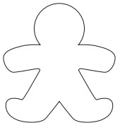
  Does not have a line of symmetry | 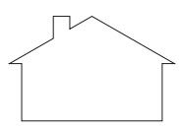
  3D Shapes
  Faces, Edge and Verticies
  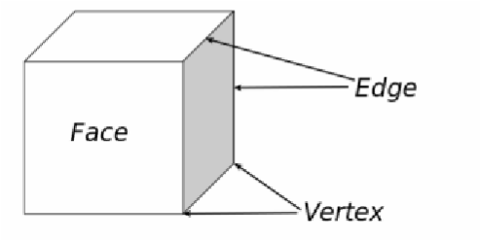
  Turns
  Quarter Turn  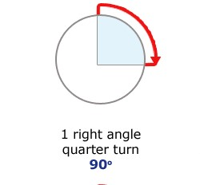 | Three-quarter Turn  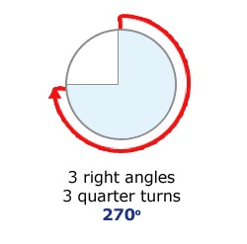
  Time
  Quarter Past | 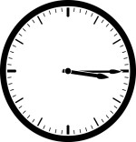 | The minute hand points to three and the hour hand points past the hour.
  Quarter To | 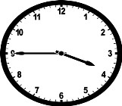 | The minute hand points to nine and the hour hand points near the next hour.
  Numbers to 1000
  100 | one hundred | 600 | six hundred
  200 | two hundred | 700 | seven hundred
  300 | three hundred | 800 | eight hundred
  400 | four hundred | 900 | nine hundred
  500 | five hundred | 1000 | one thousand
Place Value Grid
 | hundreds | tens | ones
Numeral | 100 | 10 | 1

