How is the stickman feeling? Why?
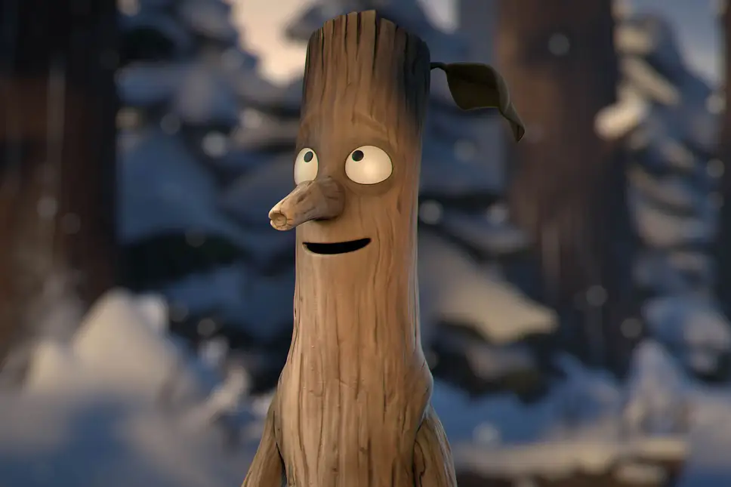

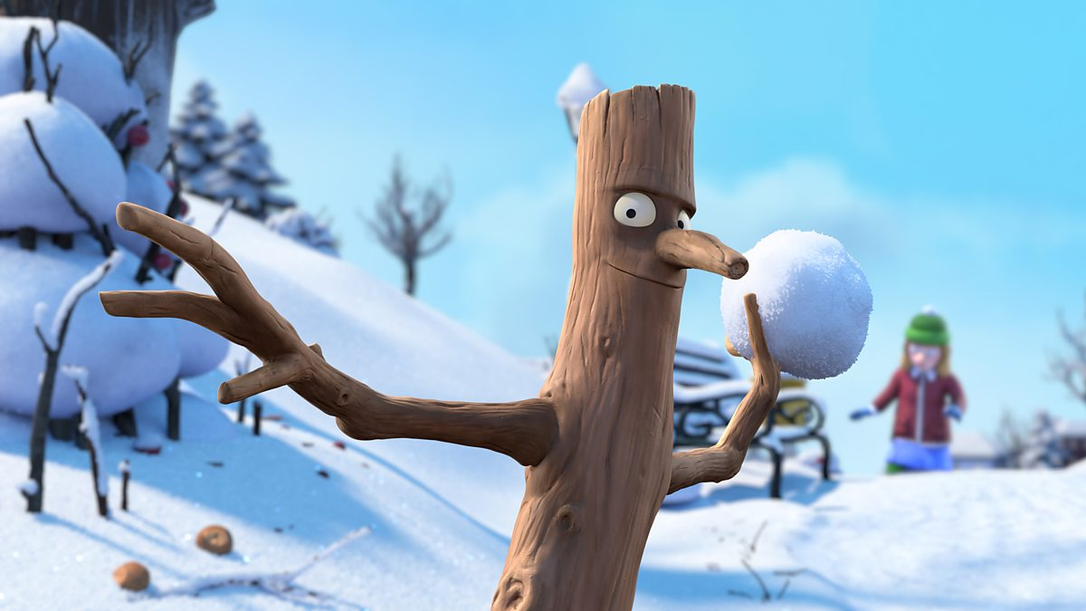
What do you think the stickman is doing here?

