
Regents Park Community Primary School
Year 3 Home Learning suggested timetable 2019 – 2020

Week beginning  30.03.20 | PE including Outdoor Learning  9:00 – 9:30 | English including SPAG  9:30 – 10:30 | 10.30-10.45 | Maths  10:45 – 11:45 | 11.45-12.45 | Reading for Pleasure  12.45 – 1:15 | Topic  1:15 – 3.00
Monday | Joe Wicks Daily Challenge  https://www.youtube.com/watch?v=4wzoy_J3I_c  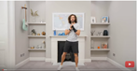 | Handwriting Practise  A) Watch: warm up activities for handwriting lessons video to give you some fun ways to help children’s control for writing.  https://global.oup.com/education/content/primary/teaching-support/pages/nelson-handwriting/?region=uk  B) Then on this website, ensure your child practices each letter:  https://www.kizphonics.com/learn-to-write-uppercase-a-lowercase-a/  C) Practise on a piece of paper their handwriting with a pencil.  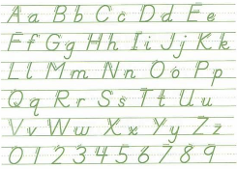 | Snack/  Break | Practise writing 1-20 forwards and backwards. By the end of the week they should be able to do this independently :)  They can write 1-10 forwards and backwards as we were practising this in school. I know they get confused with 9 and 7; 12 and 20 so hopefully practise will help.  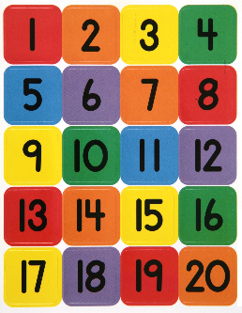 | Lunch  /break | Online books can be found at https://readon.myon.co.uk/library/browse.html  | http://www.gwydir.demon.co.uk/jo/mosaic/mkmosaic.htm  Logon and create your own exciting Roman mosaic pattern  
Tuesday | Joe Wicks Daily Challenge  https://www.youtube.com/watch?v=4wzoy_J3I_c | A) Practise these handwriting joins with Year 1 or 2 words.  B)Try and create a sentence using these words ☺  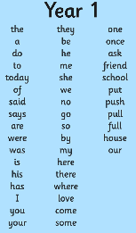 | Snack/  Break | A quick Math's activity: say a number to your child from 1-20 and they have to go and collect that amount using any household objects. For instance: 4 - they could collect 4 pens or 4 cushions.  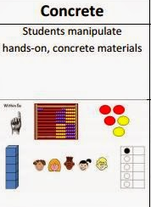 | Lunch  /break | Watch Newsround and discuss what is happening in the wider world.   | Computing  https://www.bbc.co.uk/bitesize/topics/zf2f9j6/articles/z3c6tfr  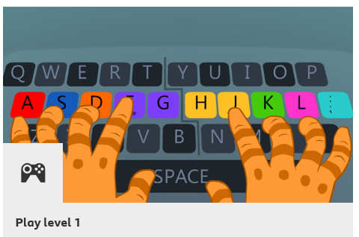  Welcome to Dance Mat Typing, a fun way to learn touch typing.  There are four levels to play, each divided into three stages.  How quick will you become at typing?
Wednesday | Joe Wicks Daily Challenge  https://www.youtube.com/watch?v=4wzoy_J3I_c | Play the Year 1 Common Exception word game. Activity http://www.ictgames.com/littleBirdSpelling/ To say and spell the words.  B) Your parents will test you on the spellings afterwards.  A weekly test. | Snack/  Break | Accelerated Maths - Log in and complete practice activities    Same log in as Accelerated Reader. Just click on Accelerated maths instead of reader when you have logged in.  Your teacher would have given you your login at parents evening. | Lunch  /break | Online books can be found at https://readon.myon.co.uk/library/browse.html Choose a sentence they are struggling with. Write it out, cut it up for them to rearrange, say it and write it. They should then colour or point to the capital letter and full stop. | Art:  Make a thank you card for the NHS and send it in the post if you can to a hospital of your choice.  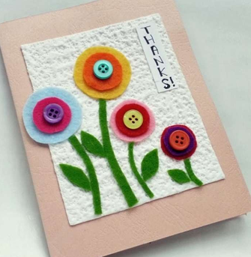
Thursday | Joe Wicks Daily Challenge  https://www.youtube.com/watch?v=4wzoy_J3I_c | Phonics play:  This will be continuous each week. Start with Phase 2 and complete one tab to start. Work your way through each week, one at a time. If you would like to do 2 in one day you can but follow the order on the website.  http://phonicsplaycomics.co.uk/comics.html   | Snack/  Break | Read and write numbers in words:  http://www.snappymaths.com/year3/y3number/y3number5.htm | Lunch  /break | Learning to read fun website:  https://www.roythezebra.com/  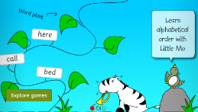 | Space: Use the national geographic kids' website to learn all about space. Create a poster with your favourite facts.  https://www.natgeokids.com/uk/discover/science/space/ten-facts-about-space/  
Friday | Joe Wicks Daily Challenge  https://www.youtube.com/watch?v=4wzoy_J3I_c | https://new.phonicsplay.co.uk/resources  Phonics games resources  Start from phase 2. Play the free games.   | Snack/  Break | Hit the button: 2, 5 and 10 times tables. https://www.topmarks.co.uk/maths-games/hit-the-button  Before completing the game, you could write down the times tables with them on a piece of paper. This game is fun, they love playing it at school so hopefully it is a lovely way recognise and remember their times tables.  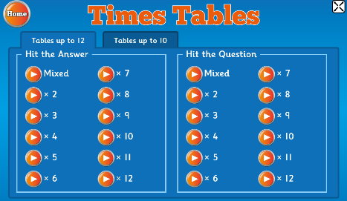 | Lunch  /break | Pick out 3 of your favourite books and explain why they are your favourite books. Can they remember the authors name? What genre is it? Fiction (not real) or nonfiction (facts)? What is the book about? Why is that one their favourite?   | RE: Create a fact file about the celebration of Easter.  Why and how is it celebrated?  https://www.bbc.co.uk/bitesize/topics/ztkxpv4/articles/z4t6rj6  

