Phonics play
https://www.phonicsplay.co.uk /
Make your own buried treasure game.
Make real words and pseudo words ( not real words eg. Sot, kot & sed ) game.
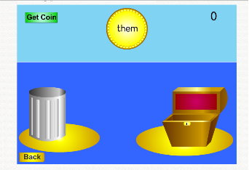
Then using the real words make sentences.
Hair – My sister has curly hair.

