Globes
From space, the Earth looks like a sphere, or ball, containing land and water.
A globe is a model of the Earth and shows what it looks like from space.
Some globes show how the land is divided into different countries - around 200 of them.
All the countries on our planet are located in seven different continents :
- Europe
- Africa
- North America
- South America
- Asia
- Oceania
- Antarctica
It shows all seven continents.
Antarctica is a special case. The continent contains no countries, instead it is governed under a 1959 agreement called the Antarctic Treaty which was signed by 12 nations, including the United Kingdom.
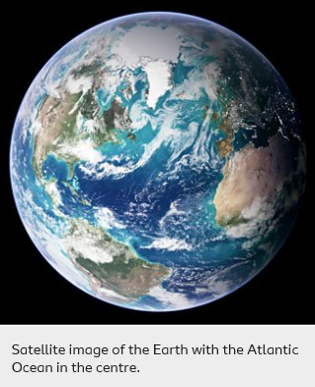Satellite image of the Earth with the Atlantic Ocean in the centre.

Maps and atlases
Maps are useful tools to help people find their way to and from somewhere.
They are much easier to carry than a globe and much more detail can be added to them.
Maps can show the whole world, a single country or even a single town or village.
Maps of different countries can be put together in a book called an atlas or they can be on a single sheet of paper.
These can be useful to carry when you go walking so you do not get lost.
In the past, maps were hand-drawn by using careful measurements of the ground.
Today, computers and tablets show aerial photographs, which are photographs taken from space by satellites and joined together to make very detailed images.
Some are so detailed that you can zoom in and see a birds-eye view of where you live.

TEST time on the next page:

