Stonehenge:
Stonehenge is one of the world’s most famous monuments. It stands on Salisbury Plain, in Wiltshire, and its giant stones can be seen from miles around.
There is great mystery surrounding when and why Stonehenge was built. Watch this short video to find out more.
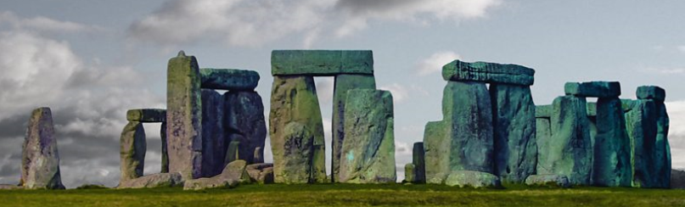
Stonehenge was built over many hundreds of years. Work began in the late Neolithic Age, around 3000 BC. Over the next thousand years, people made many changes to the monument. The last changes were made in the early Bronze Age, around 1500 BC.

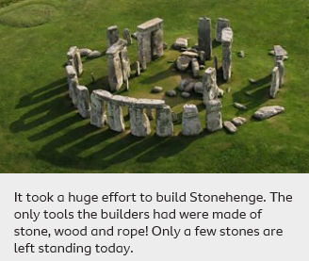
How was Stonehenge built?
The first task was to cut the boulders into shape. Archaeologists believe that the ancient Britons hammered wedges of wood into cracks in the stone. When the wood was soaked in water, it expanded and split the stone. Next, the builders used chisels and hammers to shape them.
The stones were then transported to the building site. They were probably carried on rafts down rivers, then dragged overland by teams of men and oxen. It's believed that the stones were placed on giant wooden sledges and pulled along the ground using log rollers.
The builders dug deep ditches for the stones. Then they pulled on ropes to raise them and packed the ditches with rocks to hold the stones in place.

What was Stonehenge for?
Why did the ancient Britons build such a massive monument at Stonehenge? What exactly went on at this sacred site?
Some people think that Stonehenge was used to study the movements of the Sun and Moon. Other people think it was a place of healing.
The ancient Britons believed that the Sun and Moon had a special power over their lives. It is very likely that they held special ceremonies at Stonehenge on Midsummer’s Day (the longest day of the year) and on Midwinter’s Day (the shortest day of the year). Today many people still gather at Stonehenge to celebrate Midsummer's Day, also known as the Summer Solstice.
Many experts believe that Stonehenge was used for funerals. They suggest that people carried the dead along the River Avon, and then walked up to Stonehenge in a grand procession.

Go Jitter facts:
Stone henge is a mysterious circle of standing stones built a long time ago thousands of years ago.

It is made up of 79 really heavy stones carried across land and water long before the invention of cranes and boats.

Some people say the stones were arranged to say what time of year it was
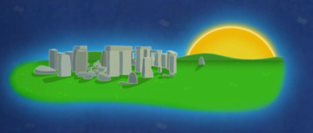 The sun rises next to the hill stone.

Activity:

Create a fact file on Stonehenge.

